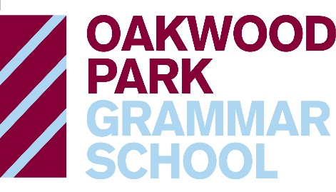

OAKWOOD PARK GRAMMAR SCHOOL
SUPPLEMENTARY FORM FOR PUPIL PREMIUM INFORMATION

To qualify for Pupil Premium you have to be eligible under one of the following criteria:

Ever 6 FSM
The pupil premium will include pupils recorded in the January school census before application who are known to have been eligible for free school meals (FSM) in any of the previous 6 years, as well as those first known to be eligible at that January.

Children adopted from care or who are in care
The pupil premium will include pupils who were looked after by an English or Welsh local authority immediately before being adopted or who left local authority care on a special guardianship order or child arrangements order (previously known as a residence order).

- Please fill in the details below and send the form back to the school with your evidence.
- Please remember to also fill in a Secondary Common Application Form either online via www.kent.gov.uk/ola or by paper SCAF and return to Kent County Council.

CHILD’S DETAILS
Forename | Surname | Date of Birth
Address (this address will be used on all future correspondence unless otherwise notified. Please use house numbers and names where applicable).

Postcode
Current School Name and Address

PARENT/CARER DETAILS
Title: Forename: Surname:

Relationship to Child

Telephone Numbers | 1. | 2.

Email Address:

Print Name | Signature

Please return to: admissions@opgs.org

