aqa a level literature OPTION A
Poetry Pre-Reading
2022-2023
English Department Oakwood park Grammar school

Welcome to A Level Literature! (Good choice if we do say so ourselves!)

This is your poetry booklet.

It will be invaluable for your wider reading and broadening your knowledge of the literary canon, which will be particularly useful for Unseen sections of your exams.

Over the summer, please look at the poetry in this booklet and attempt the tasks outlined therein. They are short and snappy and can be done in between dips in the pool – or even on your lunch break at work!

There are also some information as to different types of poetry – Renaissance, Metaphysical, Romantic and Modern – so that you will know what you are looking at and will have an overall idea of what these poets were trying to achieve.

- Please come to your first Literature lesson with your poetry booklet complete and willing to discuss your ideas with other members of your class.

Most importantly, enjoy the time to read.

We look forward to hearing your thoughts on these poems in September.

English Department
ROMANTIC POETS:
Romanticism was a philosophical, literary, artistic and cultural era which began in the mid/late-18th century as a reaction against the prevailing Enlightenment ideals of the day (Romantics favored more natural, emotional and personal artistic themes).
Their style was characterized by being actively engaged in trying to create a new kind of poetry that emphasized intuition over reason and the pastoral over the urban, often eschewing consciously poetic language in an effort to use more colloquial language. Wordsworth himself in the Preface to his and Coleridge's Lyrical Ballads defined good poetry as “the spontaneous overflow of powerful feelings,” though in the same sentence he goes on to clarify this statement by asserting that nonetheless any poem of value must still be composed by a man “possessed of more than usual organic sensibility [who has] also thought long and deeply;” he also emphasizes the importance of the use of meter in poetry (which he views as one of the key features that differentiates poetry from prose).

Major poets

- William Blake (1757-1827)
- George Gordon Byron (1788 - 1824)
- Samuel Taylor Coleridge (1732-1834)
- Percy Bysshe Shelley (1792-1822)
- John Keats (1795 - 1821)
- Elizabeth Barret Browning (1806-1861)
- William Wordsworth (1770-1850)
- Hannah Morehttp://en.wikipedia.org/wiki/Henry_Vaughan (1745-1833)

MODERNIST POETS:
Modernism is a philosophical movement that, along with cultural trends and changes, arose from wide-scale and far-reaching transformations in Western society in the late 19th and early 20th centuries. Among the factors that shaped Modernism were the development of modern industrial societies and the rapid growth of cities, followed then by the horror of World War I. Modernism also rejected the certainty of Enlightenment thinking, and many modernists rejected religious belief.
Modernism, in general, includes the activities and creations of those who felt the traditional forms of art, architecture, literature, religious faith, philosophy, social organization, activities of daily life, and even the sciences, were becoming ill-fitted to their tasks and outdated in the new economic, social, and political environment of an emerging fully industrialized world.
Modernism emerged with its insistent breaks with the immediate past, its different inventions, 'making it new' with elements from cultures remote in time and space. The questions of impersonality and objectivity seem to be crucial to Modernist poetry, as do political motivations. A notable characteristic of Modernism is self-consciousness and a consequent experiment with classical form and structure.

Major poets

- Dylan Thomas (1914 – 1953)
- Sylvia Plath (1932 – 1963)
- Ezra Pound (1885 – 1972)
- e.e cummings (1894 – 1962)
- T.S Eliot (1888 – 1965)
- William Carlos Williams (1883 – 1963)
- Rudyard Kipling (1865 – 1936)
- W.B Yeats (1865 – 1939)

RENAISSANCE POETS:

Renaissance literature refers to European literature which was influenced by the intellectual and cultural tendencies associated with the Renaissance. The literature of the Renaissance was written within the general movement of the Renaissance which arose in 13th century Italy and continued until the 16th century while being diffused into the western world. It is characterized by the adoption of a humanist philosophy, the recovery of the classical literature of Antiquity and benefited from the spread of printing in the latter part of the 15th century.

For the writers of the Renaissance Greco-Roman inspiration was shown both in the themes of their writing and in the literary forms they used. The world was considered from an anthropocentic perspective. Platonic ideas were revived and put to the service of Christianity. The search for pleasures of the senses and a critical and rational spirit completed the ideological panorama of the period. New literary genres such as the essay (Montaigne) and new metrical forms such as the sonnet (Petrarch) and Spenserian stanza made their appearance.

Major poets

- Ben Jonson (1572 – 1637)
- Christopher Marlowe (1564 – 1593)
- Sir Walter Raleigh (1554 - 1618)
- Sir Philip Sidney (1554 – 1586)
- Edmund Spenser (1552 – 1599)

METAPHYSICAL POETS:
The metaphysical poets is a term coined by the poet and critic Samuel Johnson to describe a loose group of English lyric poets of the 17th century, whose work was characterized by the inventive use of conceits, and by speculation about topics such as love or religion.
Their style was characterized by wit and metaphysical conceits—far-fetched or unusual similes or metaphors, such as in Andrew Marvell’s comparison of the soul with a drop of dew; in an expanded epigram format, with the use of simple verse forms, octosyllabic couplets, quatrains or stanzas in which length of line and rhyme scheme enforce the sense. The specific definition of wit which Johnson applied to the school was: "... a kind of discordia concors; a combination of dissimilar images, or discovery of occult resemblances in things apparently unlike." Their poetry diverged from the style of their times, containing neither image of nature nor allusions to classical mythology, as were common.
Several metaphysical poets, especially John Donne, were influenced by Neo-Platonism. One of the primary Platonic concepts found in metaphysical poetry is the idea that the perfection of beauty in the beloved acted as a remembrance of perfect beauty in the eternal realm. Their work relies on images and references to the contemporary scientific or geographical discoveries. These were used to examine religious and moral questions.

Major poets

- John Donne (1572–1631)
- George Herbert (1593–1633)
- Andrew Marvell (1621–1678)
- Abraham Cowley (1618–1667)
- Saint Robert Southwell (c. 1561–1595)
- Richard Crashaw (c. 1613–1649)
- Thomas Traherne (1636 or 1637 – 1674)
- Henry Vaughan (1622–1695)

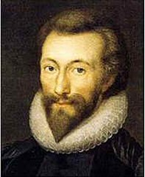
‘No Man is an Island’ – John Donne
No man is an island,
Entire of itself,
Every man is a piece of the continent,
A part of the main.
If a clod be washed away by the sea,
Europe is the less.
As well as if a promontory were.
As well as if a manor of thy friend's
Or of thine own were:
Any man's death diminishes me,
Because I am involved in mankind,
And therefore never send to know for whom the bell tolls;
It tolls for thee.
Who was John Donne? Complete 5 contextual bullet points:

1.
2.
3.
4.
5.

What sort of poet was Donne?

What is Donne exploring in this poem? What tells you this?
………………………………………………………………………………………………………………………………………………………………………………………………………………………………………………………………………………………………………………………………………………………..
Why did Hemingway call is book For Whom the Bell Tolls? How does the novel link to Donne’s poem?……………………………………………………………………………………………………………………………………………………………………………………………………………………………………………………………………………………………………………………………………………………………………………………………………………………………………………………………………………………………………………………………………………………………………………………..
‘The Definition of Love’ – Andrew Marvell

My love is of a birth as rare
As ’tis for object strange and high;
It was begotten by Despair
Upon Impossibility.

Magnanimous Despair alone
Could show me so divine a thing
Where feeble Hope could ne’er have flown,
But vainly flapp’d its tinsel wing.

And yet I quickly might arrive
Who was Andrew Marvell? Complete 5 contextual bullet points:
1.

2.

3.

4.

5.

Where my extended soul is fixt,
But Fate does iron wedges drive,
And always crowds itself betwixt.

For Fate with jealous eye does see
Two perfect loves, nor lets them close;
Their union would her ruin be,
And her tyrannic pow’r depose.

And therefore her decrees of steel
Us as the distant poles have plac’d,
(Though love’s whole world on us doth wheel)
Not by themselves to be embrac’d;

Unless the giddy heaven fall,
And earth some new convulsion tear;
And, us to join, the world should all
Be cramp’d into a planisphere.

As lines, so loves oblique may well
Themselves in every angle greet;
But ours so truly parallel,
Though infinite, can never meet.

Therefore the love which us doth bind,
But Fate so enviously debars,
Is the conjunction of the mind,
And opposition of the stars.
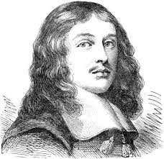

What is Marvell exploring in this poem? What tells you this?
…………………………………………………………………………………………………………………………………………………………………………………………………………………………………………………………………………………………………………………………………………………………………………………………..………………………………………………………………………………
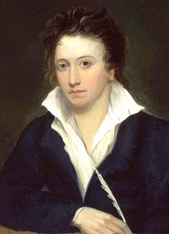
‘Ozymandias’ – Percy Shelley
I met a traveller from an antique land
Who said: Two vast and trunkless legs of stone
Stand in the desert. Near them on the sand,
Half sunk, a shatter'd visage lies, whose frown
And wrinkled lip and sneer of cold command
Tell that its sculptor well those passions read
Which yet survive, stamp'd on these lifeless things,
The hand that mock'd them and the heart that fed.
And on the pedestal these words appear:
"My name is Ozymandias, king of kings:
Look on my works, ye Mighty, and despair!"
Nothing beside remains: round the decay
Of that colossal wreck, boundless and bare,
The lone and level sands stretch far away.
What sort of poet was Shelley?

What is Shelley articulating about ego and power in this poem? What tells you this?
………………………………………………………………………………………………………………………………………………………………………………………………………………………………………………………………………………………………………………………………………………………………………………………………………………………………………………………………………………………………………………………………………………………………………………………………………………………………………………………………………………………………………………………………………………………………………………………………………………………………………………………………………………………………………………………………………………………………………………………………………………………………………………………………………..
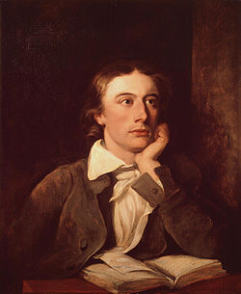
‘Ode to Melancholy’ – John Keats

Though you should build a bark of dead men's bones,
And rear a phantom gibbet for a mast,
Stitch creeds together for a sail, with groans
To fill it out, bloodstained and aghast;
Although your rudder be a Dragon's tail,
Long sever'd, yet still hard with agony,
Your cordage large uprootings from the skull
Of bald Medusa; certes you would fail
To find the Melancholy, whether she
Dreameth in any isle of Lethe dull

Who was John Keats? Complete 5 contextual bullet points:

1.
2.
3.
4.
5.

What sort of poet was Keats?
What is Keats exploring about melancholy in this poem? What tells you this?
………………………………………………………………………………………………………………………………………………………………………………………………………………………………………………………………………………………………………………………………………………………………………………………………………………………………………………………………………………………………………………………………………………………………………………………………………………………………………………………………………………………………………................
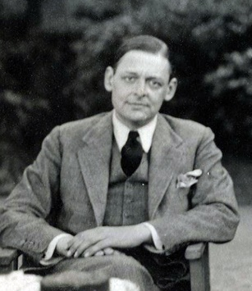
Extract from ‘The Love Song of J. Alfred Prufrcok’ – T S Eliot

Let us go then, you and I,
When the evening is spread out against the sky
Like a patient etherized upon a table;
Let us go, through certain half-deserted streets,
The muttering retreats
Of restless nights in one-night cheap hotels
And sawdust restaurants with oyster-shells:
Streets that follow like a tedious argument
Of insidious intent
To lead you to an overwhelming question ...
Oh, do not ask, “What is it?”
Let us go and make our visit.

In the room the women come and go
Talking of Michelangelo.

The yellow fog that rubs its back upon the window-panes,
The yellow smoke that rubs its muzzle on the window-panes,
Licked its tongue into the corners of the evening,
Lingered upon the pools that stand in drains,
Let fall upon its back the soot that falls from chimneys,
Slipped by the terrace, made a sudden leap,
And seeing that it was a soft October night,
Curled once about the house, and fell asleep.

And indeed there will be time
For the yellow smoke that slides along the street,
Rubbing its back upon the window-panes;
There will be time, there will be time
To prepare a face to meet the faces that you meet;
There will be time to murder and create,
And time for all the works and days of hands
That lift and drop a question on your plate;
Time for you and time for me,
And time yet for a hundred indecisions,
And for a hundred visions and revisions,
Before the taking of a toast and tea.

What do you think the full poem is about? How does this extract exemplify this? What tells you this?
…………………………………………………………………………………………………………………………………………………………………………………………………………………………………………………………………………………………………………………………………………………………………………………………………………………………………………………………………………………………………………………………………………………………………………………………….
Extract from ‘Telling Tales’ – Patience Agbabi

Tabard Inn to Canterb'ry Cathedral,
Poet pilgrims competing for free picks,
Chaucer Tales, track by track, it's the remix
From below-the-belt base to the topnotch;
I won't stop all the clocks with a stopwatch
when the tales overrun, run offensive,
or run clean out of steam, they're authentic
and we're keeping it real, reminisce this:
Chaucer Tales were an unfinished business.

What sort of poet is Patience Agbabi?
What do you think “Chaucer Tales were an unfinished business” means? Why do you think Agbabi has re-written Chaucer? How does it compare to the Prologue of Chaucer’s? What difference does it make to the poetry if you watch it being performed?
(Youtube: Patience Agbabi Prologue to the Canterbury Tales)
………………………………………………………………………………………………………………………………………………………………………………………………………………………………………………………………………………………………………………………………………………………………………………………………………………………………………………………………………………………………………………………………………………………………………………………………………………………………………………………………………………………………………………………………………………………………………………………………………………………………………………………………………………………………………………………………………………………………………………………………………………………………………………………………………………………………………………………………………………………………………………………………………………………………………………………………………………………………………………………………………………………………………………………………………………………………………………………………………………………………………………………………………………
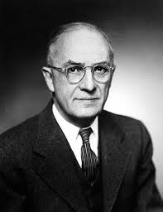
‘This is just to say’– William Carlos Williams
I have eaten
the plums
that were in
the icebox

and which
you were probably
saving
for breakfast

Forgive me
they were delicious
so sweet
and so cold

What sort of poet is William Carlos Williams?

Why was this poem written? How could this be interpreted as a comment on William’s relationship with his wife? What tells you this?
…………………………………………………………………………………………………………………………………………………………………………………………………………………………………………………………………………………………………………………………………………………………………………………………………………………………………………………………………………………………………………………………………………………………………………………………………………………………………………………………………………………………………………………………………………………………………………………………………………………………................
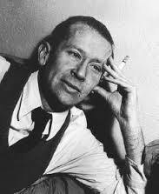
‘I carry your heart’ – e e cummings

i carry your heart with me(i carry it in
my heart)i am never without it(anywhere
i go you go,my dear;and whatever is done
by only me is your doing,my darling)
i fear
no fate(for you are my fate,my sweet)i want
no world(for beautiful you are my world,my true)
and it’s you are whatever a moon has always meant
and whatever a sun will always sing is you

here is the deepest secret nobody knows
(here is the root of the root and the bud of the bud
and the sky of the sky of a tree called life;which grows
higher than soul can hope or mind can hide)
and this is the wonder that's keeping the stars apart

i carry your heart(i carry it in my heart)

What sort of poet is e e cummings?
Why do you think cummings only uses parentheses and no other punctuation? How does it emphasise what the poem is about? What sort of relationship is being portrayed? How do you know?
……………………………………………………………………………………………………………………………………………………………………………………………………………………………………………………………………………………………………………………………………………………………………………………………………………………………………………………………………………………………………………………………………………………………………………………………………………………………………………………………………………………………………………………………………………………………………………………………………………………………………………………………………………………………………………………………………………………………………………………………………………………………………………………………………………………………………………………………………………………………………………………………………………………………………………………………………………………………………………………………………………………………………………………………………………………………………………………………………………………………………………………………………………………………………………………………………………………………………………………..............................
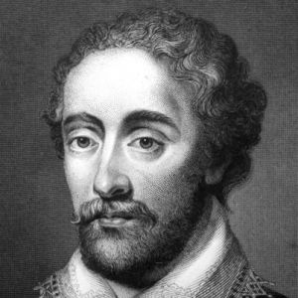
‘My Love is like to Ice’ – Edmund Spenser
My love is like to ice, and I to fire:
How comes it then that this her cold so great
Is not dissolved through my so hot desire,
But harder grows the more I her entreat?
Or how comes it that my exceeding heat
Is not allayed by her heart-frozen cold,
But that I burn much more in boiling sweat,
And feel my flames augmented manifold?
What more miraculous thing may be told,
That fire, which all things melts, should harden ice,
And ice, which is congeal'd with senseless cold,
Should kindle fire by wonderful device?
Such is the power of love in gentle mind,
That it can alter all the course of kind.

What sort of poet was Spenser?
What is Spenser exploring about love in this poem? What tells you this?
……………………………………………………………………………………………………………………………………………………………………………………………………………………………………………………………………………………………………………………………………………………………………………………………………………………………………………………………………………………………………………………………………………………………………………………………..
Read Pablo Neruda’s poem ‘I Do Not Love You, Except that I Love You’ How do the themes in this Spanish poem link to Spenser’s poem?
………………………………………………………………………………………………………………………………………………………………………………………………………………………………………………………… .………………………………………………………………………………………………………………………………………………………………………………………………………………………………………………………………………………………………………………………………..………………………
Are there any other famous literary examples that use the juxtaposition of fire and ice?
……………………………………………………………………………………………………………………………………………………………………………………………………………………………………
‘SIMPLEX MUNDITIIS’ – Ben Jonson

Still to be neat, still to be dressed,
As you were going to a feast;
Still to be powdered, still perfumed:
Lady, it is to be presumed,
Though art's hid causes are not found,
All is not sweet, all is not sound.
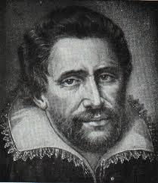
Give me a look, give me a face,
That makes simplicity a grace;
Robes loosely flowing, hair as free:
Such sweet neglect more taketh me
Than all the adulteries of art;
They strike mine eyes, but not my heart.
Who was Ben Jonson? Complete 5 contextual bullet points:

1.
2.
3.
4.
5.

What sort of poet was Jonson?
The title is interesting. Where does it come from? What is it an homage to?
…………………………………………………………………………………………
Look at Herrick’s poem ‘Delight in Disorder’ and the following quotes. What are Jonson and these authors saying about beauty?
“There is no excellent beauty that hath not some strangeness in the proportion.”—Sir Francis Bacon (1561-1626).
“The absence of flaw in beauty is itself a flaw”.—Havelock Ellis (1859-1939).
“In nature, nothing is perfect and everything is perfect. Trees can be contorted, bent in weird ways, and they're still beautiful”.—Alice Walker (1944- ).
………………………………………………………………………………………………………………………………………………………………………………………………………………………………………………………………………………………………………………………………………………………………………………………………………………………………………………………………………………………………………………………………………………………………………………………………………………………………………………………………………………………………………………………………………………………………………………………………………………………………………………………………………………………………………………………………………………………………………………………………………………………………………………………………………..

