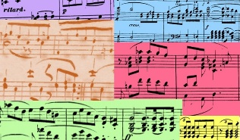
Music A Level Taster Work Summer 2021

Summary of Tasks:

Task | Purpose of task | Time to be taken | Outcome Expected
COMPOSITION
Revision of Compositional Techniques | To revise and build on prior knowledge, new skills, leading to other tasks | 1 ½ hours | Notes and examples on manuscript paper
The making of Gladiator – The Soundtrack | To be inspired and to learn the processes of a film composer | 4 hours | Observation notes and examples – at least 500 words
Film clips composition | To use knowledge gained from previous tasks, to create film inspired music, to practice notation skills | Ongoing but at least 1 hour per day | Notated composition for x3 film clips
HISTORY
Listening Journal | To listen to new music, to build repertoire, to improve listening skills, to create listening bank for wider listening aspect of course | Ongoing but suggested 1 new piece per week | Listening Journal Table
Research + Comparison Essay | To listen to new pieces, to improve listening skills, to build research skills, to use knowledge of musical elements, to be able to compare, to be able to structure an essay | At least 10 hours, including listening and writing up | Essay 1000 words maximum
PERFORMANCE
Practice log | To complete regular practice, to expand repertoire, to improve skills/techniques | Ongoing  At least 1 hour per day | Practise log
What makes a great musical performance? | To observe ‘great’ performers, to evaluate your own performance skills, to form your own opinions about performers | 3 hours | Either as a table or a piece of written work maximum 400 words

COMPOSITION

TASKS:
1. Watch the following YouTube clips to help you to revise and learn new techniques when creating harmony and melody.
Using manuscript paper, take notes from the clips as you may need them later in this task.

YouTube clips:
Advanced Music Theory – Harmony https://www.youtube.com/watch?v=-xZ6m1vBQg8
Advanced Music Theory – Melody https://www.youtube.com/watch?v=ei652x61Tbk
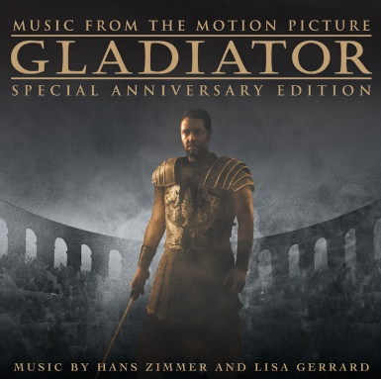
Film Scoring: What the Pros Know/Getting started https://www.youtube.com/watch?v=7J8KrZjs6uk

2. Watch the following documentary on YouTube (in 3 parts).
Hans Zimmer – making of GLADIATOR soundtrack 1/3, 2/3. 3/3
https://www.youtube.com/watch?v=_JAlOTl84yc
https://www.youtube.com/watch?v=mg824E6K7nI
https://www.youtube.com/watch?v=OGPoJvQhhKk

Make notes about Zimmer’s inspirations as he creates the music for the film.
Comment on his work ethic – where does he work? on his own? what equipment? etc.
How does he match his music to the scenes in the film?

3. Select a film of your choice. Select x3 contrasting clips from the film, no longer than 2 minutes each. Turn the sound off and compose your own music to match the x3 clips.
Consider: characters, scenery, action, mood, storyline, instruments, sounds
Either hand-write or use music software to write out your music.
(www.musescore.org is a free music writing software – please do not buy anything especially)
Hint: create a time planner down to the second of the action on screen, to help you match your music.

HISTORY

1. For your set works, it is important to keep a detailed Listening Journal.
TASK:
Listen to at least 1 new classical piece of music per week and record your observations in your Listening Journal. Comment on: title, composer, date, style, country of origin, musical features, structure, harmony, melody, rhythm, dynamics etc.
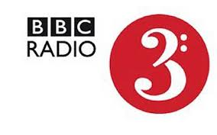
Use the following sites to access a variety podcasts and information about pieces and composers:
BBC Radio 3 Composer of the Week https://www.bbc.co.uk/programmes/b006tnxf/episodes/player
https://www.bbc.co.uk/programmes/p02nrvd3/episodes/downloads
https://www.classicfm.com/composers
https://www.bbc.co.uk/podcasts/category/music - for a full range of music styles
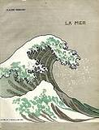
Present your Listening Journal as a table – an example of a template below, but you can design your own. (This will be an ongoing piece of work throughout your whole course)
Title | Composer and country | Date of composition | Musical features
e.g. La Mer | Debussy, France | 1903-1905 | Programme music, orchestral…etc.

2. Here are x6 suggested pieces to listen to and study. Each 1 is linked to each of your 6 Areas of Study – they are not your set works.
1. J.S. Bach- Brandenburg Concerto No.4, mvt.1
2. Mozart- Marriage of Figaro – Aria ‘Dove sono’, Monserrat Cabelle
3. Beethoven- Symphony No.9, mvt.4, Barenboim/W.Eastern Divan Orchestra
4. Debussy- La Mer – Lucerne Festival Orchestra, Claudio Abbado
5. Stravinsky-The Firebird – Gergiev – Vienna Philharmonic Salzburg Fest.2000
6. Reich- Different Trains – London Contemporary Orchestra – Boiler Room

TASKS:
1. Listen to them all on YouTube.
2. Add them to your Listening Journal.
3. Select 2 of them and complete the following as an essay. 1000 words max.
a) Research into the composers and the pieces.
b) Discuss the similarities and differences between the 2 pieces, using key musical elements E.g. structure, context, timbre/sonority, harmony, melody, rhythm, dynamics, tempo, tonality etc. Try to give examples as your evidence. (although this could be difficult without the score) e.g. the 1st theme in the 1st 8 bar phrase.

PERFORMANCE

TASKS:
1. Continue to practice your instrument/s.
Keep a Practice Log of the techniques and pieces you have learnt.

2. Watch the following YouTube video:
Top 10 Greatest Live Musical Performances https://www.youtube.com/watch?v=LcUXh41ttRk
Select 2 ways in which each of these performances are labelled as ‘greatest live musical performances’.

3. Compile your own Top 10 best music performances of all time.
Consider all instruments, not just your own, a mixture of styles (rock, classical etc), live events, specific songs. Justify what makes each one a great performance. Consider which aspects you could use to make your performances ‘great’!
Hint: stage presence, venue, lighting, audience communication, body language etc.

