Welcome to A level Religious Studies Taster Tasks 2022

Included in this pack are the following activities:
Title of Tasks | Purpose of Task: | Time to be taken | Outcome Expected
Task 1: Ethics | Enquiry into ethical concepts.  Develop understanding of absolute and relative morality.  Applying examples. | 2 hours | 500-800 words.
Task 2: Philosophy | Understanding of the contrasting Philosophies of Plato and Aristotle. | 5 hours | Detailed notes and labelled diagrams (see below for details)
Task 3: Wider Research | Early familiarity with key thinkers/philosophies.  Practice note-making skills. | Open Ended | Keep a research journal.

Task 1: Ethics
Scenario: I’m on school lunch duty and I see and hear a boy saying nasty things to another boy while they’re eating their shepherd’s pie.
Questions:
- Why is it OK, and my duty, to tell him off for being unkind?
- Why is it not OK for me to tell him off for eating meat (if I’m vegetarian)?
And then:
- Which, if any, of our beliefs are ‘just a matter of personal preference’ and which, if any, refer to some kind of absolute fact? Explain your reasons fully with examples if possible.

- Should we leave others to their ‘personal preference’ in matters of religious belief, or are some religious beliefs right and others wrong in an absolute sense? Explain your reasons fully with examples if possible.

- Is there an ultimate truth, an absolute right and wrong, about religious truth claims? Explain your reasons fully with examples if possible.

- At what point, if any, does one culture have the right to tell another ‘you’re doing it wrong’ over matters of religion and ethics? Explain your reasons fully with examples if possible.

- To what extent, if at all, do people have an obligation to share their religious faith with others – or should we keep our beliefs to ourselves and try and respect the views of others even if we think they’ll miss out on going to heaven? Explain your reasons fully with examples if possible.

Task 2: Philosophy
Listen to the following two podcasts
https://thepanpsycast.com/panpsycast
- Episode 1 –Plato’s Cave
- Episode 2 –Aristotle’s Basic Philosophies

- Listen to both podcasts and take your own notes on the main ideas of Plato and Aristotle.

- Find a picture of Plato’s Cave like the one below and label it in as much detail as you can from listening to the podcast and your own research.

- Find a picture of Aristotle’s Four Causes like the one below and label it in as much detail as you can from listening to the podcast and your own research.

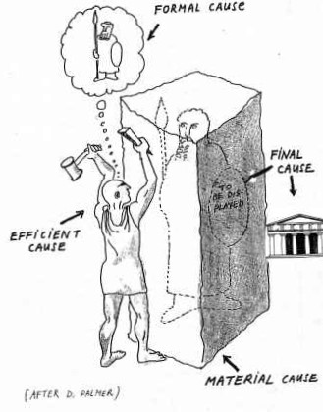
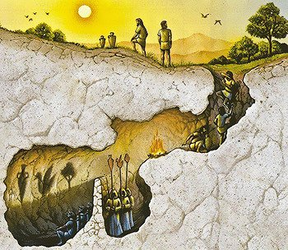

Task 3: Wider Research
Get to know some of the philosophers you will meet during your A level course.
https://www.bbc.co.uk/programmes/p01f0vzr
(They are quite long and heavyweight, don’t worry too much if you don’t understand it all)

- Pick one of the philosophers/concepts below.
  - Practice your note-making skills by pausing and writing a summary of what you’ve heard so far.
  - Think about whether you agree with what the philosopher is saying and add this in another colour to your notes.

- You may choose to listen to more if you wish as part of your wider research.

Listen to whatever takes your interest. For RS, you could concentrate on the ones starred, or others from this list:

- Plato’s Republic
- ** St Thomas Aquinas
- **Augustine
- The Ontological Argument
- ** The Soul
- **Kant
- **Relativism
- **Utilitarianism
- William James
- Nietzsche
- Al-Ghazali
- **Duty
- **Good and Evil
- Altruism
- **Feminism
- **Evil
- Empiricism
- **David Hume
- Logical Positivism
- **Mill

Happy researching. If you have any queries, contact me on ltrumper@opgs.org
See you in September.

