Task 1: Reviewing Current Affairs
1. Choose 2 out of the 6 cartoons below.

2. For each cartoon:
a) Give details of the event that the cartoon is referring to.
b) What point is the cartoonist making about that event? How do you know this?
c) Provide evidence from other at least 2 other sources to support the view of the cartoon about the event or effect of the event to which it refers. Acknowledge your sources. Higher level responses will be able to comment on the political bias of the sources they choose.
d) Provide evidence from at least 2 other sources to criticise the view of the cartoon. I would like you to show that the cartoon is NOT entirely accurate about the event or effect of the event to which it refers. Acknowledge your sources.
4. Find one more political cartoon of your own from July and August and do the same with it as above. (Try @BrookesTimes on Twitter)
5. Print out your work ready for the start of term.
A) January 2022 (Compare to the Saatchi and Saatchi campaign poster for Margaret Thatcher)
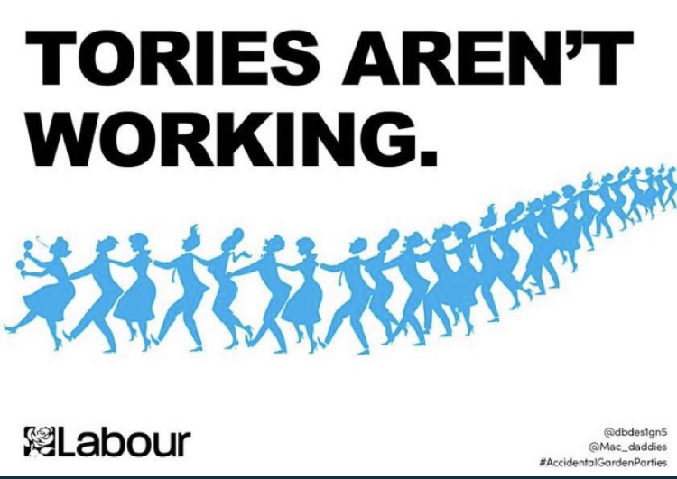

B) February 2022 Private Eye front cover
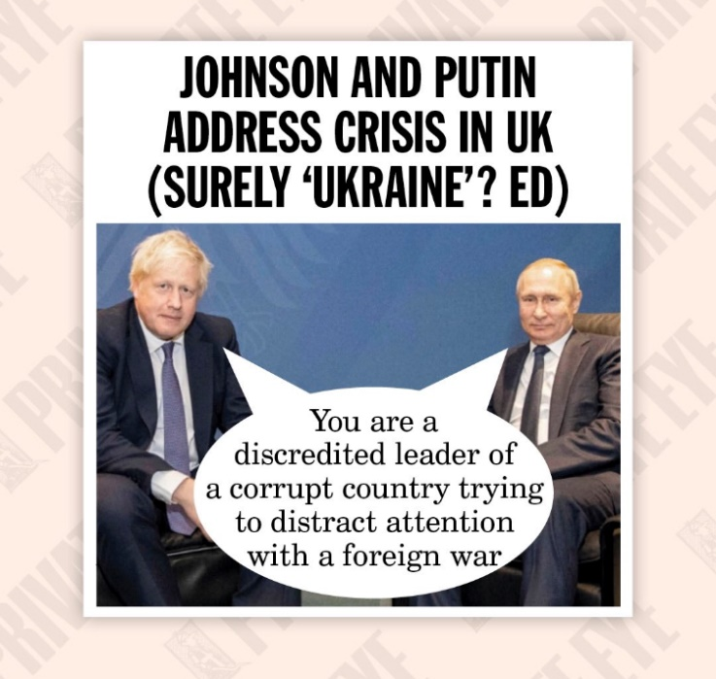

c) February 2022 The Met Police
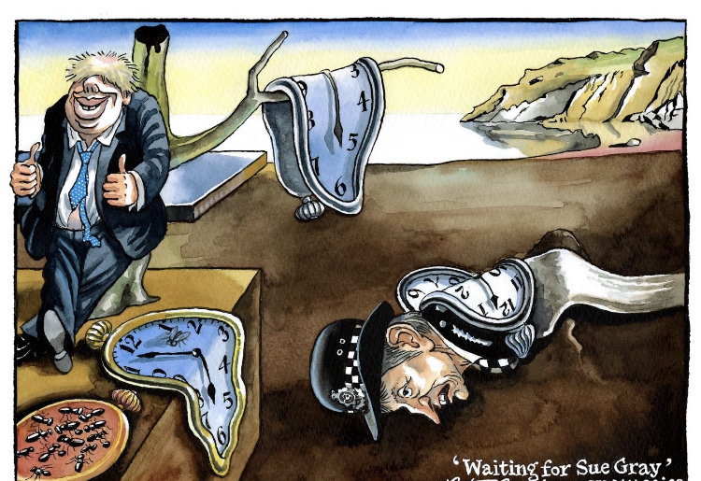

D) The Chancellor
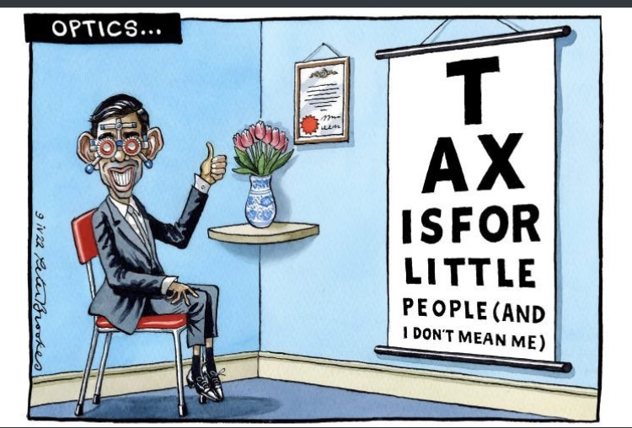
E) February 2022 Brexit Bus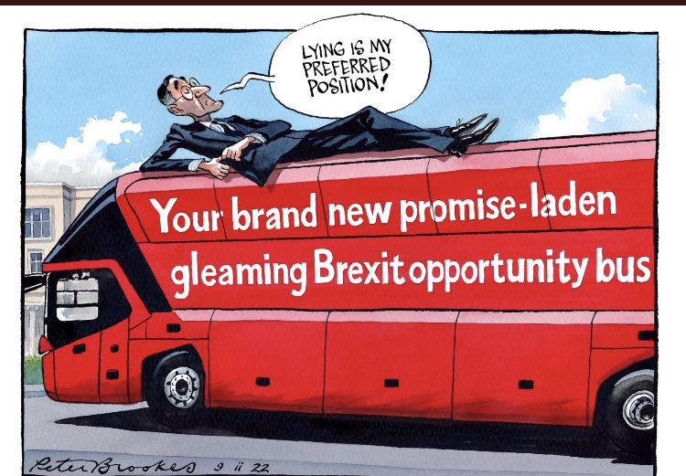

F) Sue Gray May 2022
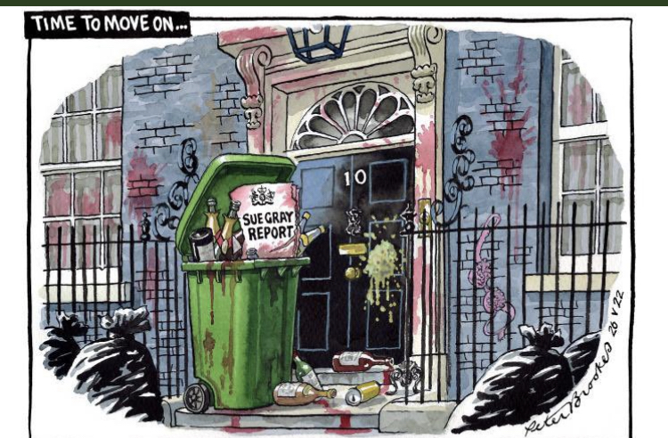

G. Levelling Up
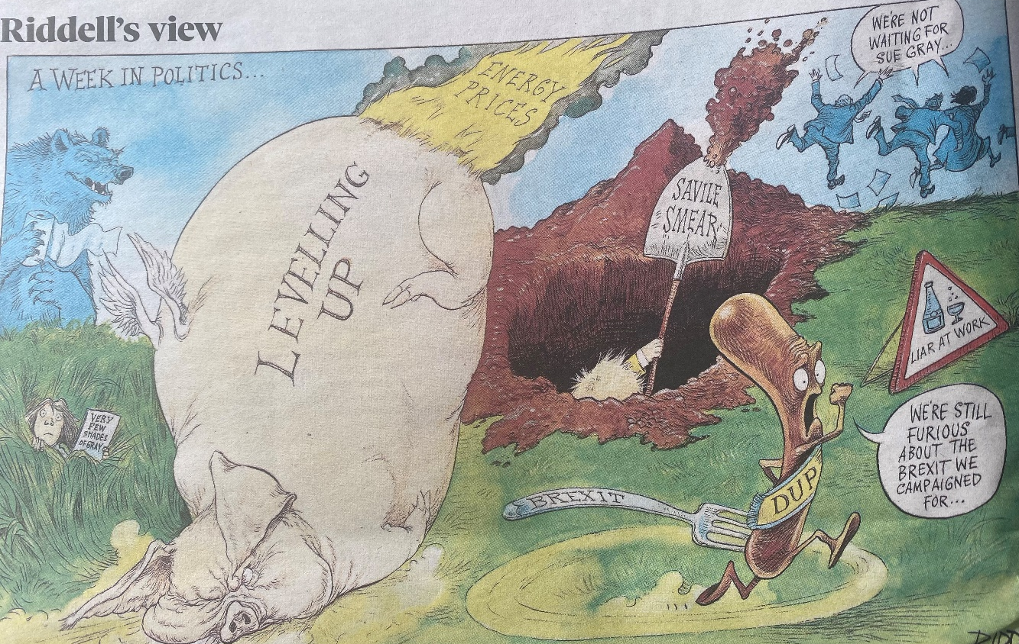

Task 2: Political Ideology
https://www.politicalcompass.org/

1. Take the test.
2. Before you get your results at the bottom of the page, use the text to answer these questions:
a) What is the difference between a left wing authoritarian and a left wing libertarian?
Give examples to support your point.
b) What is difference between communism and neo-liberalism in terms of economics?
3. Find your chart position which will appear at the bottom of the page.
4. Go back and choose 3 statements from pages 1 to 4 of the test. For each statement explain why you made your choice. To support your explanation, use at least 4 statistics/events (quote your sources) from the past 20 years and clearly explain why you have chosen these events.
5. Ask other members of your family or your friends to take the test. Where do they stand?

