History Summer Preparation Work 2022: Italy and English History Units

Overview/ guidance for Italy work:
Title of Tasks | Purpose of Task: | Time to be taken | Outcome Expected
Task 1: Definitions | Learn key terms. | 20 mins | Historical vocabulary improved.
Task 2: Overview clip | Identify key events  Begin to learn chronology | 30 mins | Notes
Task 3: Timeline and paragraph | Develop deeper knowledge of Italian unification | 1 hour | Images and timeline to accurately detail events
Task 4: Podcasts and notes | Provide evidence to explain importance of the major challenges Italy faced | 1 hour | Key challenges explained

Overview / guidance for English History work:
Title of Tasks | Purpose of Task: | Time to be taken | Outcome Expected
Task 1: Documentaries | Become familiar with key events and people | 1 hour | Key facts and outline of events identified in paragraphs
Task 2: Podcasts and articles | Develop detailed knowledge of the period | 1.5 hours | Able to explain and recognise the role of key people and key events
Task 3-4 Additional research and write up | Build accurate and detailed accounts with key terms | 1.5 hours | Notes on Wars of the Roses causes and profiles of individuals.

Italy Unit: Italy 1896 – 1943
Our course starts in 1896: a troubled time in many ways for the relatively new Kingdom of Italy. The big themes behind these tasks here are issues about how was the Kingdom of Italy created and how well did politicians deal with immediate challenges within the country.
Completing this work will give you background and context to the unit by examining events leading up to the start of our course in 1896. It will also introduce you to key historical concepts which we will refer to frequently. You will be meeting new characters and seeing the impacts of wars you have not previously studied for GCSE, for example, the Napoleonic Wars and the Italian Wars of Independence, but remember this is background for your course only.
Our tip is to take it a step at a time as you complete each task using your skills from GCSE – key terms, events in order, importance of events etc. We look forward to picking up this work with you when you start this unit.
You can save this file and type your answers into it, or you can handwrite your work.
1. Use the internet to write a definition or summary of each of these concepts. Please make sure you understand what your write – no copy and paste. Suggested length is a detailed sentence for each:

a) renaissance
b) political Liberalism
c) centralised government
d) republic
e) nationalism
f) socialism
g) Risorgimento
h) Napoleonic Wars
i) suffrage
j) Chamber of Deputies (Italy)
k) anti-clerical

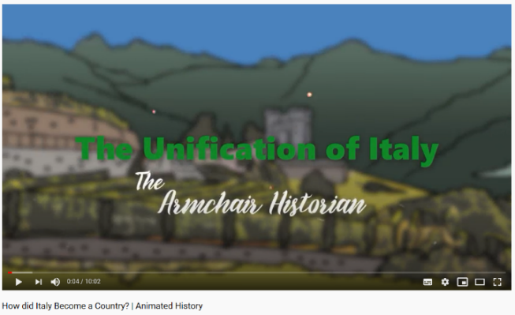
2. Watch and answer the questions below https://www.youtube.com/watch?v=vGM54x0LsII
a) How did Italians traditionally identify themselves?
b) Which countries fought in Italy in the C15th and C16th?
c) Why was i) Mazzini ii) Count of Cavour iii) Garibaldi important? (you can also research this online – one sentence for each).
d) Who became the first King of Italy and when?
e) What challenges were there to the newly united Italy? Aim for at least three.

3a) Using the attached article from History Today Magazine, and your own further online research if needed, complete this chart to trace the steps which led to the creation of Italy by 1871. Each row refers to a section of the article.
Find a photo, cartoon, map or other relevant image online for each one and screen clip it into your chart as below.

 | Key points | Did this make Italy more unified?
Italy in the early 19th Century  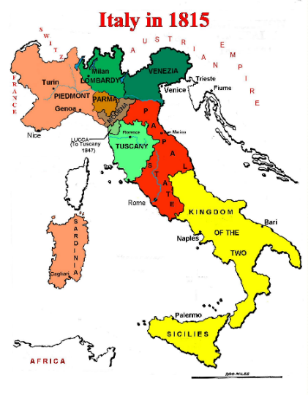 | The Italian land was divided into 11 states. France had dominated these until 1815 and after this Austria did – sometimes by direct rule or by putting family members in charge. There were unsuccessful revolutions in 1820 and 1830. The goal of these was to remove Austrian influence. | No – Italian states ruled differently to each other. No overall Italian leader and it was barely even a dream to have an Italian-run, unified Italy at this stage.
Mazzini, Giaberti and Balbo
The 1848-49 Revolutions
Victor Emmanuel and Cavour
The First War of Italian liberation
Garibaldi
Risorgimento completed
Sum up in 200 words how Italy was unified by 1871?

3. Use the hyperlinks to find the Podcasts no. 18 Was Italian unification a success between 1861 and 1870 and no. 19 The completion of Italy and her on-going problems:
https://www.mixcloud.com/italianunification/episode-18-how-successful-was-the-new-state-of-italy-after-1860/
https://www.mixcloud.com/italianunification/episode-19-the-completion-of-italy-and-her-on-going-problems/
As you listen, make notes (this can be bullet-point style) for each of these six challenges Italy faced. Aim for 5+ points for each. Obviously pause it as you go.
- Continuing differences between North and South
- The problems caused by “Piedmontisation” (Ie. all of Italy effectively being taken over and run by those from the North)
- The Brigand’s war
- The disillusionment of the radicals and democrats after 1860
- The attitude of the Catholic Church to the new state
- The effect of the death of Cavour

English History Unit: England 1445–1509: Lancastrians, Yorkists and Henry VII

- Watch the following documentary https://www.youtube.com/watch?v=SB_OThWd-eA
After each episode write a short summary (one short paragraph for each)

- Listen to the following podcasts. You will find it helpful to make brief notes on each one as you listen and read – aim for 10 points for each.

When complete, answer questions 3-6 by also completing additional research online. Remember to include dates, names, people, places.
- https://www.historyextra.com/period/medieval/henry-vi-terrible-king/ (35 mins)
- https://www.historyextra.com/period/plantagenet/house-york-princes-tower-thomas-penn-wars-roses/ (45 mins)

- What were the causes of the Wars of the Roses? 500 words

- Write a profile on the following individuals: Aim for 150-200 words minimum for each.
- Henry VI
- Richard Duke of York
- Margaret of Anjou
- Richard, Earl of Warwick
- Edward IV
- George Duke of Clarence
- Richard III
- Margaret Beaufort

