WOMAN’S HOUR
Episode: ‘Male Fertility/Holocaust Education’
Broadcast: 27th January 2021
Host: Emma Barnett
Emma has been hosting Woman’s Hour since January 2021.. Emma hosts several shows across BBC Radio and Television. She also writes regularly for The Sunday Times.
Contributor in this extract:
Rhod Gilbert
Rhod Gilbert is a popular stand-up comedian and has appeared on television shows such as Never Mind The Buzzcocks and was the presenter of his own programme, Rhod Gilbert’s Work Experience on BBC One.

The Show
In this episode, Emma hosts a long and frank discussion around male fertility with comedian Rhod Gilbert who was on the programme to speak about his experiences as cross promote a documentary he has made for the BBC on the subject, Rhod Gilbert: Stand Up To Fertility. As the programme was broadcast on Holocaust Memorial Day, Emma also led a discussion on how to teach young children about the Holocaust.
The programme strand was originally broadcast at 10am on January 27th, 2021. It was later that day made available to download on the BBC Sounds app. The programme was broadcast live.

Things to Listen For
- Does the content fit the remit of the BBC: to inform, educate and entertain? Does it also fit the remit of BBC Radio 4?
- Is this programme considered ‘niche’? Consider the vocabulary of the contributors, the format of the programme and the content
- Why feature so prominently a male guest? What links does his story have potentially with listeners?
- Would this episode be MORE accessible to a male audience? Why?

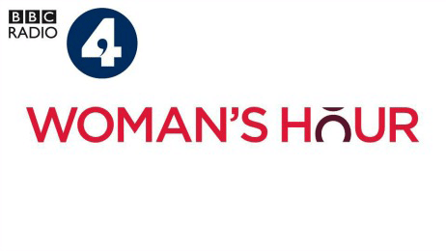
Timecode for the episode
0.00-16:05- Introduction to the programme and the topics under discussion, a reminder of ways to get in touch with the programme and the interview with Rhod Gilbert.

Theory
Consider how you could apply the theories below as you listen to the broadcast:
Theorist | Theory Basics
Curran & Seaton | - The media is controlled by a small number of companies driven mostly by profit and power  - Media concentration generally limits or inhibits variety, creativity and quality  - More socially diverse patterns of ownership help to create the conditions for more varied and adventurous media productions
Livingstone and Lunt | - There is a struggle between the need to further the interests of citizens (by protecting them from harmful or offensive material) and the need to further the interests of consumers (by providing choice, value for money and market competition)
Stuart Hall (Reception)  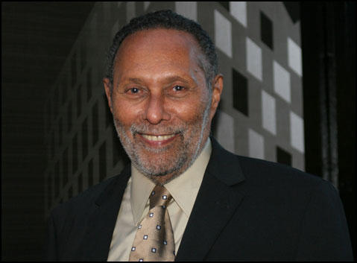 | - Communication is process involving encoding by producers (putting messages and ideologies IN the text) and decoding (the audience taking those meanings OUT and processing them.)  - There are three positions the audience can take when they decode these messages-  - Dominant (Hegemonic) position- the encoded meanings are fully understood and accepted by the audience  - Negotiated position- the encoded messages are accepted in a general way but the message is adapted or negotiated to better fit in to the individual’s experiences or context  - Oppositional position- the encoder’s message is understood, but the decoder (the audience member) disagrees with it, reading it in an opposite way.
Van Zoonen (Feminist) | - Gender is constructed through discourse (debate) and we need to consider the context both historical and cultural of the text  - Women’s bodies are objects and how they are looked at is a core element of western patriarchal (male dominated) culture  - Visual and narrative codes construct the male body as ‘spectacle’
bell hooks (Feminist) | - Feminism is a struggle to end sexist/patriarchal oppression & the ideology of domination  - Feminism is a political commitment rather than a lifestyle choice  - Race and class as well as sex determine the extent to which individuals are exploited, discriminated against or repressed.

Woman’s Hour- The Basics
Industry | Audience
Woman’s Hour is a daily programme aimed at ABC1 women (4 Cs- Reformers, Explorers, Mainstreamers) broadcast on BBC Radio 4 and made available as a podcast on BBC Sounds. It is a mainstay of the BBC 4 schedule. BBC 4’s remit claims its programming should “should appeal to listeners seeking intelligent programmes in many genres which inform, educate and entertain.”  BBC is a publicly funded broadcaster with a remit to inform, educate and entertain.  Is a varied, creative programme which is diverse in its topics and presenters as well as guests. It offers open debate on subjects which alludes to the impartiality of the BBC.  Is now freely available to download on digitally convergent devices, appealing to a broader and younger audience who wish to experience the programme. | Deals with topical issues ranging from politics to culture and ‘the female experience’. The discussions are led by a female presenter and panels of guests and experts are given air time to speak on the topics under discussion.

Time | Quote | What this says about the audience
0.00-16.05

0.00-16.05

0.00-16.05

0.00-16.05

0.00-16.05

0.00-16.05

0.00-16.05

0.00-16.05

Exam Style Practice Questions:

Plan THREE OF EACH of these questions in PEE points. Then, once planned, choose one from each to write out fully.

‘Explode’ the question first and always include evidence from the excerpts of the programmes we have listened to OR your knowledge of the programme, its production, distribution or audience.

AUDIENCE
- How might audiences respond differently to radio? Refer to Woman’s Hour [8]
- Explain how national and global audiences can be reached through different media technologies and platforms. Refer to Woman’s Hour to support your points [8]
- How do media organisations meet the needs of niche / specialised audiences? Refer to Woman’s Hour to support your points. [12]
- Explain how producers of radio programming target audiences. Refer to Woman’s Hour [10]
- How do radio producers appeal to and maintain a variety of audiences? Refer to Woman’s Hour [12]
INDUSTRY
- How does ownership shape media products? Refer to Woman’s Hour. [12]
- To what extent is financial success important to the radio industry? Refer to Woman’s Hour to support points. [10]
- Explain how economic contexts shape radio production. Refer to Woman’s Hour. [12]
- Explore the impact of technology and digital convergence on the radio industry. Refer to Woman’s Hour. [15]
- Explain how historical, social and cultural contexts influence radio production. Refer to Woman’s Hour [15].
- Explore how radio programmes are marketed. Refer to Woman’s Hour in your answer to support your points. [8]

