WOMAN’S HOUR
Episode: ‘Wonder Woman at 80/Virginity Testing/Bridgerton/Winter’
Made available from: 15th January 2021
Host: Anita Rani

Anita has been hosting the Friday and Saturday editions of WH since 2021 and has also hosted editions during the week. She is a writer, broadcaster and television presenter. The chief host of the programme is Emma Barnett alongside Anita and Nuala McGovern.
Contributors in this episode:
Richard Holden MP (Conservative)
Richard has been the Conservative MP for Northwest Durham since 2019.
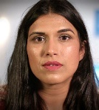 Natasha Rattu
Natasha is the Executive Director of the UK based charity Karma Nirvana, who work to end Honour Based Abuse across the UK and beyond.
Dr Naomi Crouch
Dr Crouch is the current chair of the British Society for Paediatric and Adolescent Gynaecology who also works as a consultant gynaecologist at the St Michael’s Hospital in Bristol.

G Willow Wilson
G Willow Wilson is an American comics writer who was the creator of Ms. Marvel. She converted to Islam in 2003.

The Show-Context
In this episode, a wide range of subjects are covered by Anita and her guests. These range from the legality of ‘virginity testing’ kits and the implications of Honour Based Abuse to the release of Wonder Woman 1984 on streaming and the character’s 80th birthday. Other topics up for discussion are the Netflix show Bridgerton, climate issues and listener input on how they are occupying their days during a very cold and dark winter which was, at the time, made worse through covid lockdown.
The programme strand was originally broadcast at 10am on January 15th, 2021, at 10am. The programme, like many daily programmes on Radio 4, was broadcast live. It was later that day made available on the BBC Sounds app for download.
Things to Listen For
- Does the show fit the remit of the BBC: to inform, educate and entertain? Does it also fit the remit of BBC Radio 4?
- Is this programme considered ‘niche’? Consider the vocabulary of the contributors, the format of the programme and the content
- Why would this be moved from broadcast to podcast exclusively?
- Is the programme accessible to the casual listener? Also, is it purely enjoyable only for women or can men find the broadcast accessible?
Timecodes for episode:
0.00-2.05- Introduction to the programme/run down of features/ways to get in touch with the show (email, text and social media).
02.06-14.16- Discussion on Virginity Testing
14:20-24:32- Discussion on the 80th anniversary of Wonder Woman and female superheroes
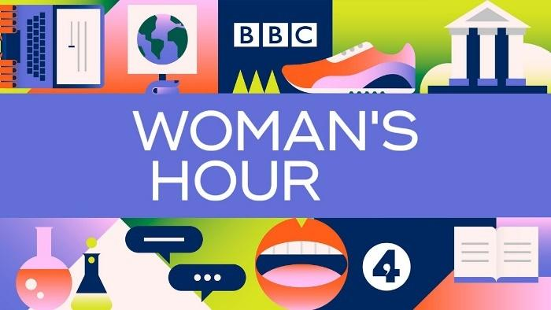

Theory
Consider how you could apply the theories below as you listen to the broadcast:
Theorist | Theory Basics
Curran & Seaton | - The media is controlled by a small number of companies driven mostly by profit and power  - Media concentration generally limits or inhibits variety, creativity and quality  - More socially diverse patterns of ownership help to create the conditions for more varied and adventurous media productions
Livingstone and Lunt | - There is a struggle between the need to further the interests of citizens (by protecting them from harmful or offensive material) and the need to further the interests of consumers (by providing choice, value for money and market competition)
Stuart Hall (Reception)  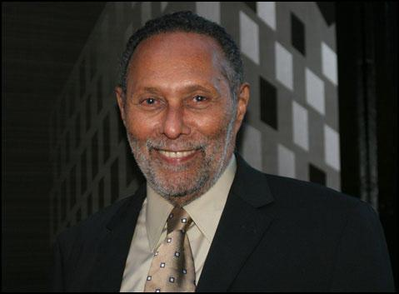 | - Communication is process involving encoding by producers (putting messages and ideologies IN the text) and decoding (the audience taking those meanings OUT and processing them.)  - There are three positions the audience can take when they decode these messages-  - Dominant (Hegemonic) position- the encoded meanings are fully understood and accepted by the audience  - Negotiated position- the encoded messages are accepted in a general way but the message is adapted or negotiated to better fit in to the individual’s experiences or context  - Oppositional position- the encoder’s message is understood, but the decoder (the audience member) disagrees with it, reading it in an opposite way.
bell hooks (Feminist)  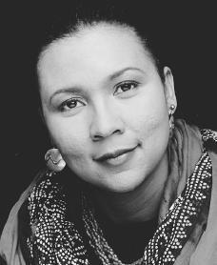 | - Feminism is a struggle to end sexist/patriarchal oppression & the ideology of domination  - Feminism is a political commitment rather than a lifestyle choice  - Race and class as well as sex determine the extent to which individuals are exploited, discriminated against or repressed.

Past Paper Questions on Late Night Woman’s Hour
Explain the impact of media technologies on audience consumption of radio. Refer to Woman’s Hour to support your points [10]
Explain how the radio industry targets audiences. Refer to Woman’s Hour to support your points [10]
Points to consider in these questions relating to Late Night Woman’s Hour
- The audience is young and relatively intelligent  - Reflects the BBC’s objective to develop services for younger listeners  - Deals with themes, some controversial, that are relevant and will appeal to the niche audience  - Presenter is a similar age to the listeners  - Guests are quite highbrow and reflect the audience  - Topics discussed in detail suggesting the needs and interests of the audience  - Programme is available across platforms and the website is an important tool to help market the programme and establish its brand identity  - Social media is appealing to the target audience and is mentioned regularly in the programme by the presenter and the contributors |  | - Text is easily accessible through digitally convergent devices such as smartphones  - The programme can be listened to through the BBC website for the show  - The importance of scheduling is now longer an issue: the show can be listened to on demand  - The availability on numerous platforms show Curran & Seaton’s idea that socially diverse patterns of ownership help to create the conditions for more adventurous production  - Radio is a global medium and digital convergence has allowed it to be just that: available everywhere at all times
Time | Content- its tone, topic (how does this affect female listeners) and approach |  | What this says about the audience
0.00-02.05 |  |  | .
2.06-14.18

2.06-14.08

2.06-14.08

2.06-14.08

2.06-14.08

14.20-24.32

14.20-24.32

14.20-24.32

14.20-24.32

What would Curran & Seaton say about Woman’s Hour?

What would Livingston & Lunt say about Woman’s Hour?

What would Stuart Hall say about Woman’s Hour?
(Reception Theory)

What would Lisbet Van Zoonen say about Woman’s Hour?

What would bell hooks say about Woman’s Hour?

For all of these exercises, think about the content of this episode.
Think about what it said, how it is said and who is saying it. It is also important to remember, as you think about what the theorists would say about this episode, the mode and method of production, the audience it is aimed at and the remit of Radio 4.

Something to colour in as you listen (if it helps you focus!)

