Welcome to A level Media Studies Taster Tasks 2022

Included in this pack are the following activities:
Title of Tasks | Purpose of Task: | Time to be taken | Outcome Expected
Task 1: Review of Newspaper Coverage & Issues of Representation | Building on Prior Knowledge/  Applying examples. | 2 hours | 500 words with pictures
Task 2: Introduction to Media Theory & Regulation | Understanding of Stuart Hall’s Theory of Representation and Noam Chomsky’s Manufacturing Consent  Early familiarity with key thinkers.  Applying examples. | 3 hours | 1000 words with pictures
Task 3: Wider Research | Improve media studies vocabulary  Develop alternative readings of an issue/event informed by theory by analysing alternative representations | Open Ended | Analysis of own issue/ event represented by the newspaper industry  3-5 slides PPT or screenshots annotated with media language.

Task 1: Review of Newspaper Coverage & Issues of Representation
1. Make a list of mind map of the media’s role in society.
2. Research Stuart Hall’s THEORY OF REPRESENTATION. Condense the key points into 3-5 bullet points
3. Stuart Hall’s THEORY OF REPRESENTATION. Watch the clip from Al Jazeera and add to your notes: https://www.youtube.com/watch?time_continue=1&v=FWP_N_FoW-I&feature=emb_logo
Create a ‘Media Studies Glossary’ - be sure in your summary of his theory, you include a clear definition of the terms:
- Representation
- Stereotype
4. What is your favourite way to access news?
5. Stretch and challenge Q - Do you know who regulates newspapers/ the press in the UK?
6. Research the IPSO and have a clear definition of how they regulate the newspaper industry.

Task 2: Introduction to Media Theory & Regulation
1.
a) Watch the clip explaining the role of the IPSO and add to your notes: https://www.youtube.com/watch?v=GKF9Tl6srW0&feature=emb_logo
b) What do you think constitutes as a misleading newspaper story? Is this any different to fake news? List 3-5 things that make a story misleading!
c) This is how the IPSO have addressed such misleading claims. Watch the clip and answer the following: Which examples can you spot? Do you think their rulings, corrections and clarifications go far enough? https://www.youtube.com/watch?time_continue=1&v=_aqr3cw2gpY&feature=emb_logo
2. Research Noam Chomsky’s THEORY OF MANUFACTURING CONSENT.
Draw a concept map to explain the theory in your own words/ include images where possible.
3. Noam Chomsky’s MANUFACTURING CONSENT
Watch the clip from Al Jazeera and add to your notes: https://www.youtube.com/watch?time_continue=2&v=34LGPIXvU5M&feature=emb_logo
4. Research the following definitions and add them to your Media Studies glossary:
- Tabloid
- Broadsheet
- Sensationalism
5. Tabloids tend to be more guilty at breaching the IPSO’s guidelines, as they often sensationalise news stories. Can you come up with a list of differences between tabloid and broadsheet publications? Create a comparative grid or double bubble map to list the differences.
6. Research the definitions of the following media terms and add them to your glossary:
- Masthead
- Buzzwords
- Captions
- Hard/ soft news
- Skyline
- Sidebar
- Headline
7. Analyse the tabloid V broadsheet representations (below) of the COVID-19 restrictions/ #FreeBritney/ Royals and annotate with how they differ in as much detail as possible:

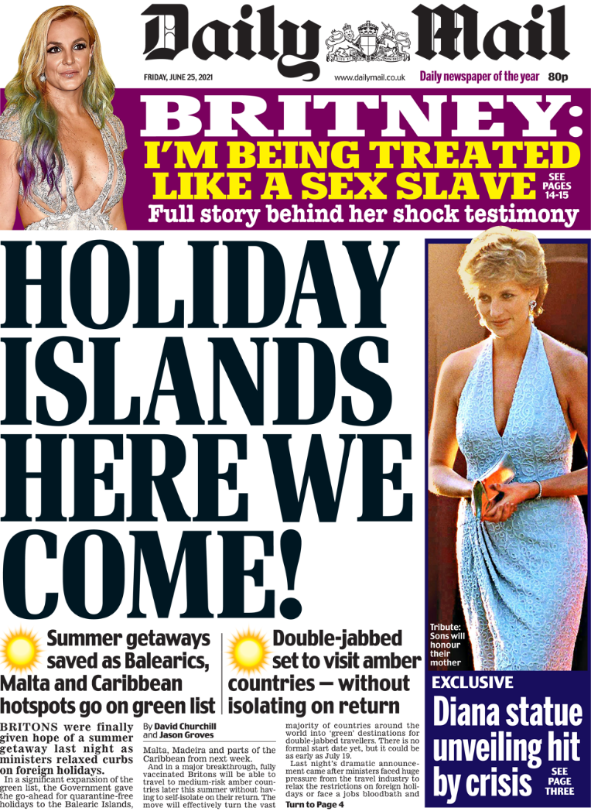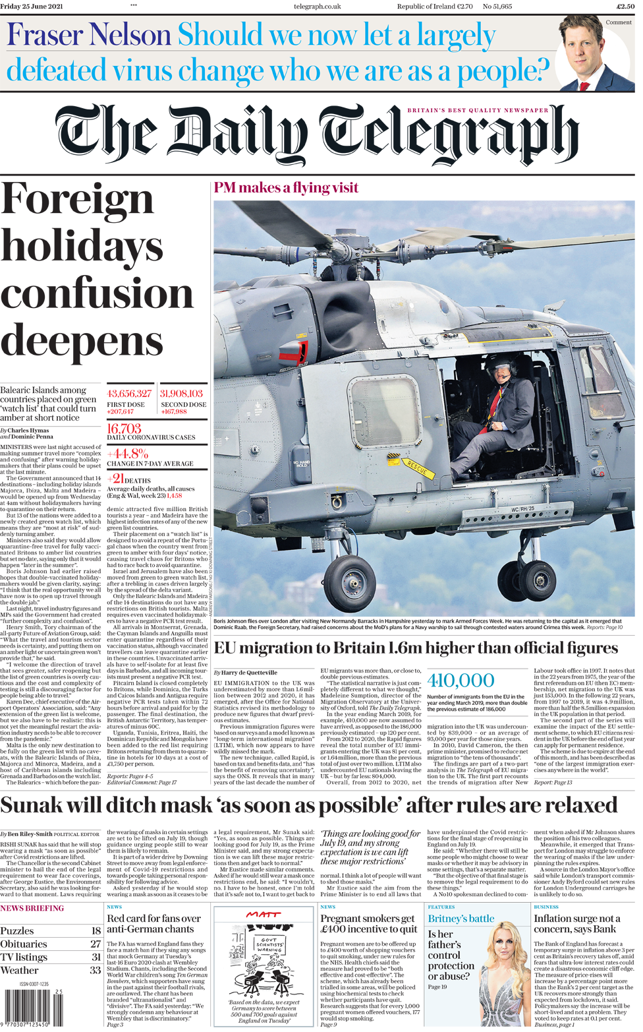

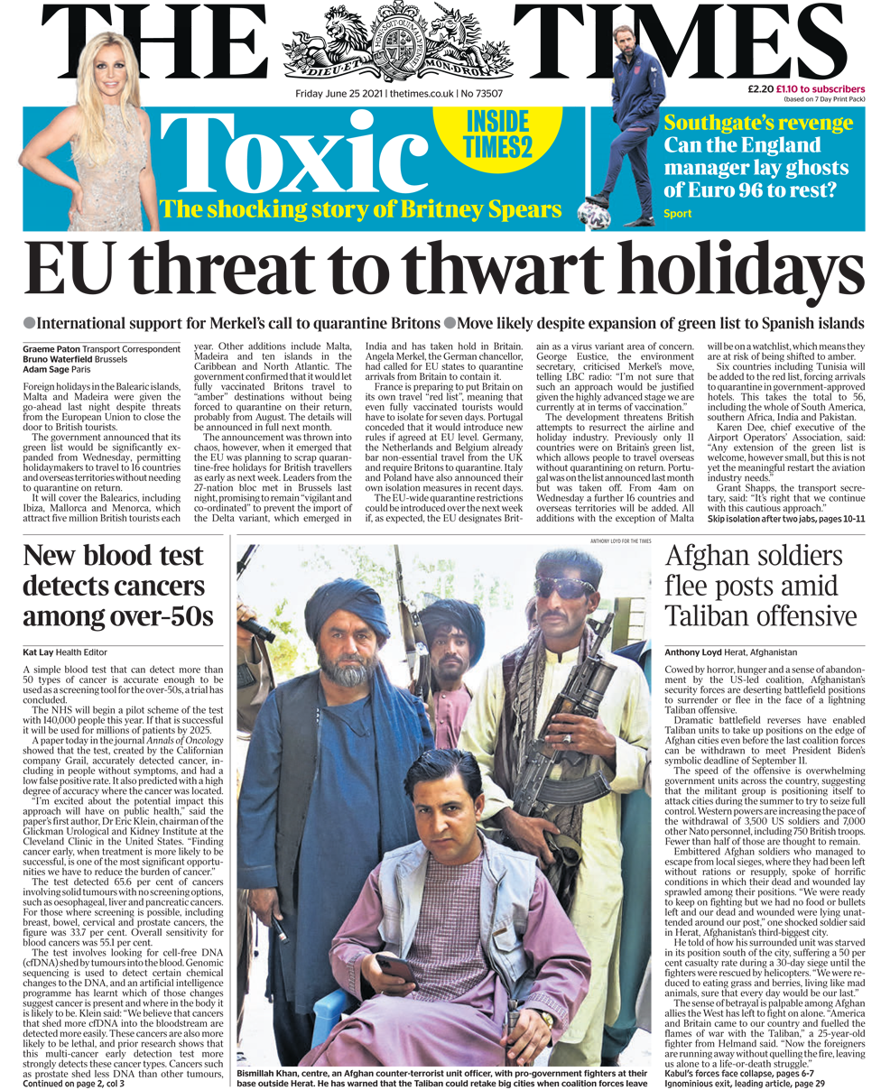

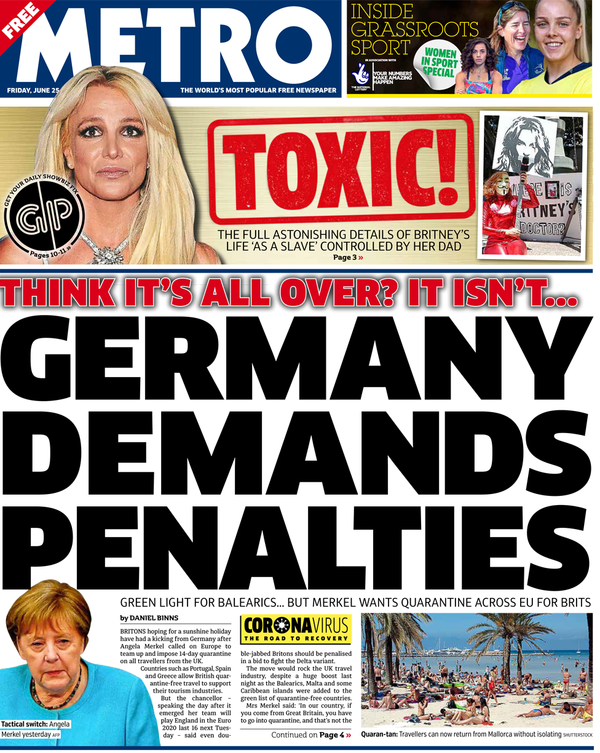

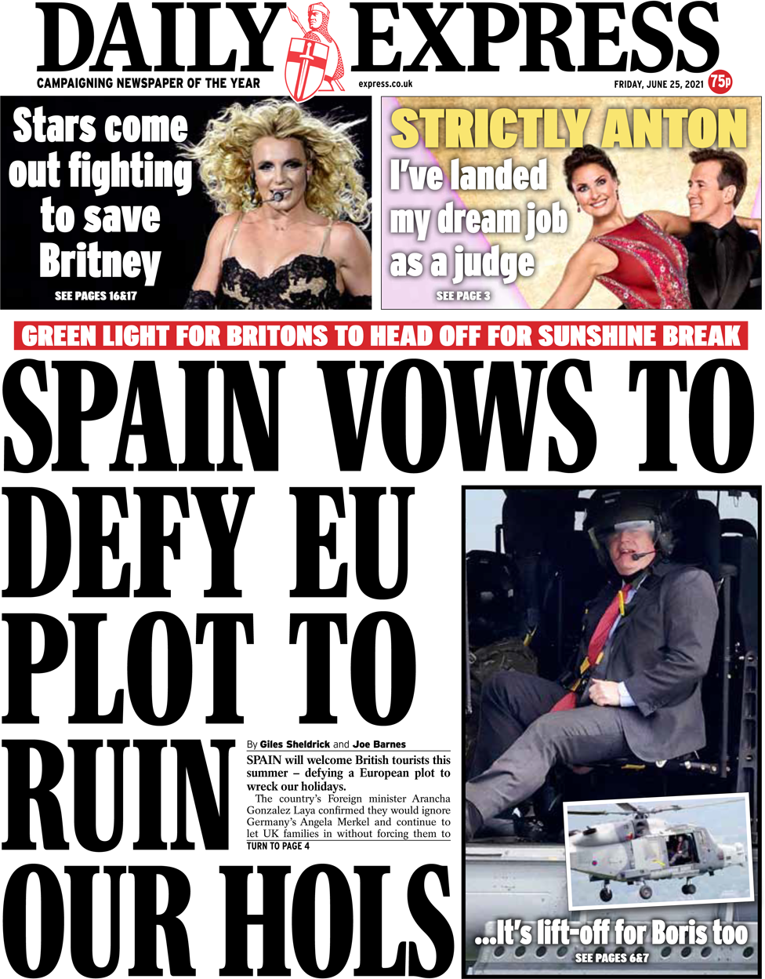

8. Listen to a podcast and see how this medium compares to more visual news like newspaper front pages? Suggested podcasts:
https://open.spotify.com/episode/7J4xxFPoBSDTJGEccv4e5D - ITV News
https://www.bbc.co.uk/sounds/play/p08888s8 – BBC Sounds
TASK 3: Wider Research
- Research your own issue/ event across the Summer holidays represented in the newspaper front pages – you can Google them online – you do not need to physically buy the papers, and be ready to explain how it uses stereotypes or sensationalism to target its audience.

- Annotate them with your analysis using all the media terminology you have got in your glossary to date.

- Apply Richard Dyer’s Theory of Representation and apply it to your chosen front pages.

