
YEAR 12 SPANISH

ORGANISING YOUR FILE

You need to complete the essays “Writing task exemplar” Page 13

A well organised file is the key to success at AS. If you keep to these guidelines you will have no difficulty in keeping yourself prepared for lessons and keeping up with what is expected of you.

Please label your file dividers as follows:

- Course information

Theme 1: La evolución de la sociedad Española
Theme 1 is set in the context of Spain only. This theme covers social issues and trends.
• El cambio en la estructura familiar: La evolución de las actitudes hacia el matrimonio, las relaciones y las familias.
• El mundo laboral: La vida laboral en España y las actitudes hacia el trabajo; las oportunidades de trabajo para los jóvenes; la igualdad de género.
• El impacto turístico en España: El impacto económico; las oportunidades que ofrece el turismo; el impacto socioambiental.

Theme 2: La cultura política y artística en el mundo hispanohablante
Theme 2 is set in the context of Spanish-speaking countries and communities. This theme
covers artistic culture (through music and festivals and traditions) and political and artistic
culture (through media).
• La música: Los cambios y las tendencias; el impacto de la música en la cultura contemporánea.
• Los medios de comunicación: La televisión y las telenovelas: los medios de comunicación escritos y en internet; el impacto en la sociedad y la política.
• Los festivales y las tradiciones: Los festivales, las fiestas, las costumbres y las tradiciones.

A2
Theme 3: La inmigración y la sociedad multicultural española
Theme 3 is set in the context of Spain only. This theme covers social issues and trends.
● El impacto positivo de la inmigración en la sociedad Española: Las aportaciones de los inmigrantes en la economía y la cultura.
● Enfrentando los desafíos de la inmigración y la integración en España: Las medidas adoptadas por las comunidades locales; la marginación y el aislamiento desde el punto de vista de los inmigrantes.
● La reacción social y pública hacia la inmigración en España: El enfoque político hacia la inmigración; la opinión pública.

Theme 4: La dictadura franquista y la transición a la democracia
Theme 4 is set in the context of Spain only. This theme covers political culture.
● La Guerra Civil y el ascenso de Franco (1936-1939): La Guerra Civil y el ascenso de Franco, los republicanos contra los nacionalistas; las divisiones en la sociedad.
● La dictadura franquista: La vida cotidiana bajo la dictadura franquista: la opresión política, la censura, las divisiones en la sociedad.
● La transición de la dictadura a la democracia: El papel del Rey Juan Carlos en la transición; el Gobierno de Suárez; el golpe de Estado de 1981.

2. Grammar

3. Oral work & oral exam preparation

- When you are given handouts, please ensure that they are filed in the appropriate section of your folder. If you miss a lesson for any reason, it is your responsibility to get a copy of anything handed out.
- It is essential that you bring your file to every lesson.
- It is your responsibility take good care of the text books you are given. They must be returned to school at the end of the course in the same state that they were given to you, so you may wish to cover them. The text books are:
  - Edexcel Spanish for A Level Hodder Education
  - Spanish Grammar Shaum’s (photocopies)
  - Complete Spanish Grammar McGrawhill (photocopies)
Your teacher will tell you which books you will need for each lesson. In general you will need the Edexcel A level book for every topic lesson, and the grammar and vocabulary books can be used at home, to supplement your class work.
- You will see the Language Assistant once a week. This is a compulsory lesson and if you know that you are going to be away you must inform her, just as you would inform your class teacher. The Language Assistant will tell you if she wants you to bring any books.
- Use your private study time to develop your independent study skills (not just to complete homework!). Use online resources such as Spanish newspapers or blogs. Useful links can be found at www.delicious.com/LanguagesRevisionArnoldSchool - use the ‘tag’ facility at the side of the page to narrow down what you want to search for.
http://www.channel4learning.com/index.html

PAPER 1 EXAM TIPS

LISTENING READING AND TRANSLATION - 2h, 80 marks, 40% of the qualification

Assessment overview
Students are not permitted access to a dictionary during the examination.
The examination is made up of:
Section A: Listening (30 marks)
A listening assessment based on a recording, featuring male and female Spanish speakers.
Students will respond to comprehension questions based on a variety of contexts and
sources.
Section B: Reading (30 marks)
A reading assessment based on a variety of text-types and genres where students will have
to respond to comprehension questions.
Section C: Translation into English (20 marks)
An unseen passage to be translated from Spanish to English.

PAPER 2 EXAM TIPS

WRITTEN RESPONSE TO WORKS AND TRANSLATION- 4 hour and 40 min, 120 marks, 30% of the qualification

Assessment overview
This paper includes a translation exercise and an extended response on either one literary
text or one film listed in Appendix 2: Prescribed literary texts and films.
Students are not permitted access to a dictionary or any documentation relating to the works
during the examination.
Students complete Section A and one question from either Section B or C.
Section A: Translation (20 marks)
Students translate an unseen passage from English into Spanish.
Section B: Written response to works (literary texts) (50 marks)
Students select one question from a choice of two for their chosen literary text. If a student
answers a question in this section then they do not complete Section C.
OR
Section C: Written response to works (films) (50 marks)
Students select one question from a choice of two for their chosen film. If a student answers
a question in this section then they do not complete Section B.

PAPER 3= SPEAKING

SPEAKING-Between 21 and 23 min, 72 marks, 30% of the qualification

Assessment overview
Students complete two tasks – Task 1 is worth 30 marks and Task 2 is worth 42 marks.
Task 1 (responding to written language and discussion based on Theme 1)
Students are provided with two texts and respond to questions on them, followed by a wider
discussion on the theme.
Task 2 (discussion on Theme 2)
Students will choose to discuss one sub-theme drawn from the main theme.

Before the exam:
You have to choose a general topic from the 4 main topics. Prepare this general topic and any of the subtopics well. Try to create yourself a bank of vocabulary, data and research about them, to be able to discuss, give opinions and argue. It might be helpful if you also could research about the topic in relation to any Spanish speaking country.

- The exam:
You have 15 minutes preparation with the stimulus. Think of possible questions to answer about the stimulus and consider further discussion points that might follow on. You have NO access to dictionary or any other resource. You can make notes in an A4 one side paper which you can refer to during the examination.
You can NOT write on the stimulus.
The stimulus is in Spanish about 70-90 words and it might be supported with a picture.
  - Section A - 7-9 minutes
The student is asked four compulsory questions by the teacher/examiner in the order
they are written:
o Question 1 requires the student to summarise the first text
o Question 2 requires the student to answer a comprehension question on the first text
o Question 3 requires the student to respond to information in the second text or both
texts
o Question 4 will stimulate wider discussion of the cultural and social context of the subtheme
beyond the focus of the texts on the stimulus card. The teacher/examiner must
ask follow-up questions for the remainder of the task time. The teacher/examiner can
use the bank of optional generic questions provided by Pearson as a guide to ensure
that the nature of the questioning allows the student to demonstrate their knowledge
and understanding of the cultural and social context and to give a critical response to
issues discussed. These can be found in the Pearson Edexcel Level 3 Advanced
● Questions may be repeated, but rephrasing is not allowed.
  - Section B – 5-6 minutes
The student is asked four compulsory questions by the teacher/examiner in the order
they are written:
o Question 1 requires the student to summarise the first text
o Question 2 requires the student to answer a comprehension question on the first text
o Question 3 requires the student to respond to information in the second text or both
texts
o Question 4 will stimulate wider discussion of the cultural and social context of the subtheme
beyond the focus of the texts on the stimulus card. The teacher/examiner must
ask follow-up questions for the remainder of the task time. The teacher/examiner can
use the bank of optional generic questions provided by Pearson as a guide to ensure
that the nature of the questioning allows the student to demonstrate their knowledge
and understanding of the cultural and social context and to give a critical response to
issues discussed.
● Questions may be repeated, but rephrasing is not allowed.

SPEAKING MARK SCHEME- 72 marks

Task 1 (responding to written language and discussion based on Theme 1)

Responding to written language in speech (AO2)
Marks Description
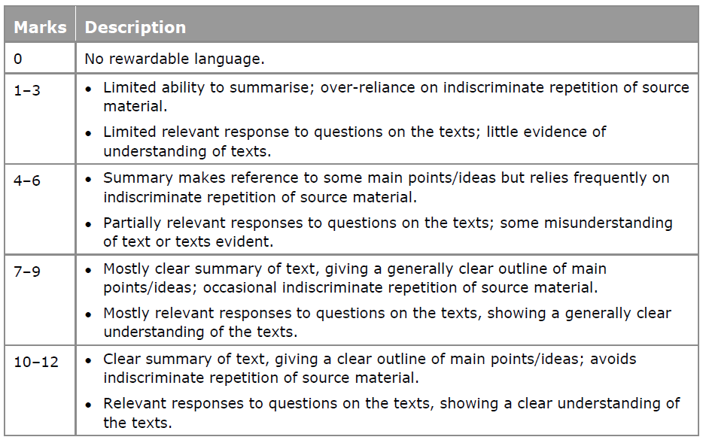

The knowledge and understanding of society and culture (AO4)
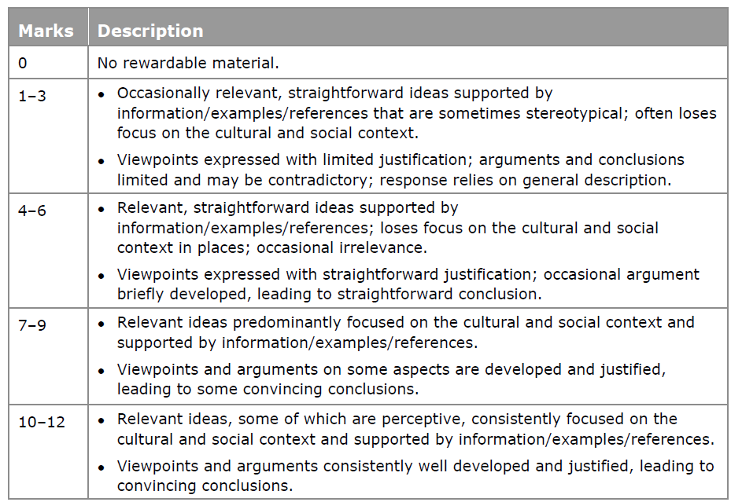
Interaction (AO1)

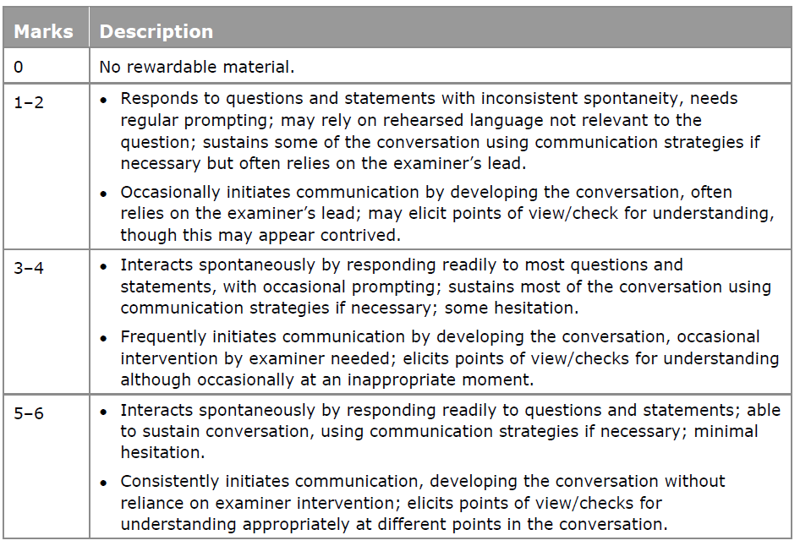

Accuracy and range of language (AO3)
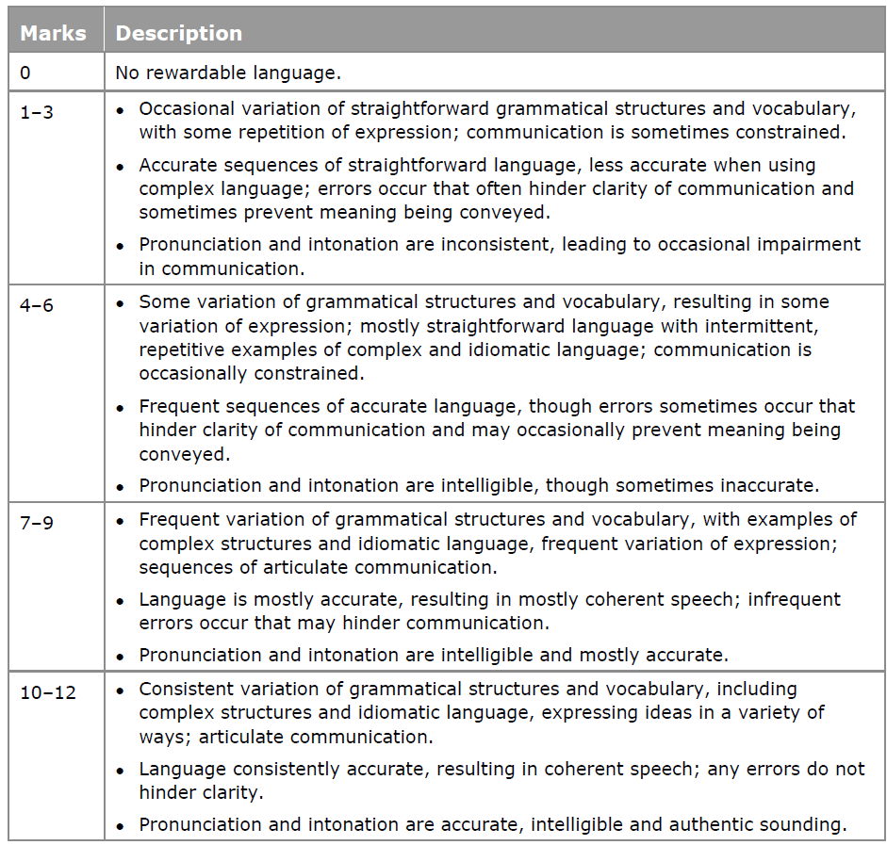

Task 2 (discussion on Theme 2)
Knowledge and understanding of society and culture (AO4)
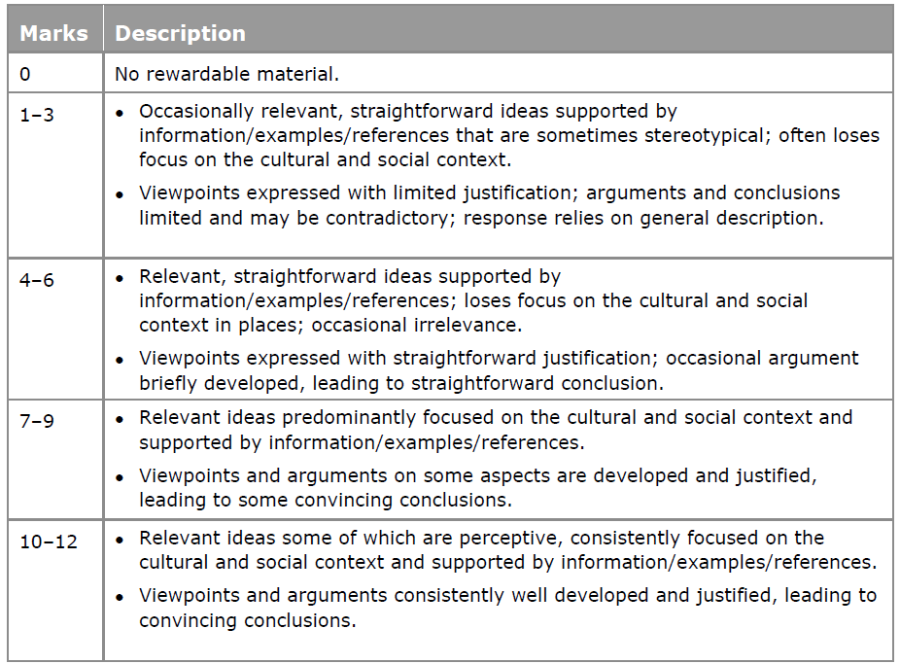
Accuracy and range of language (AO3)
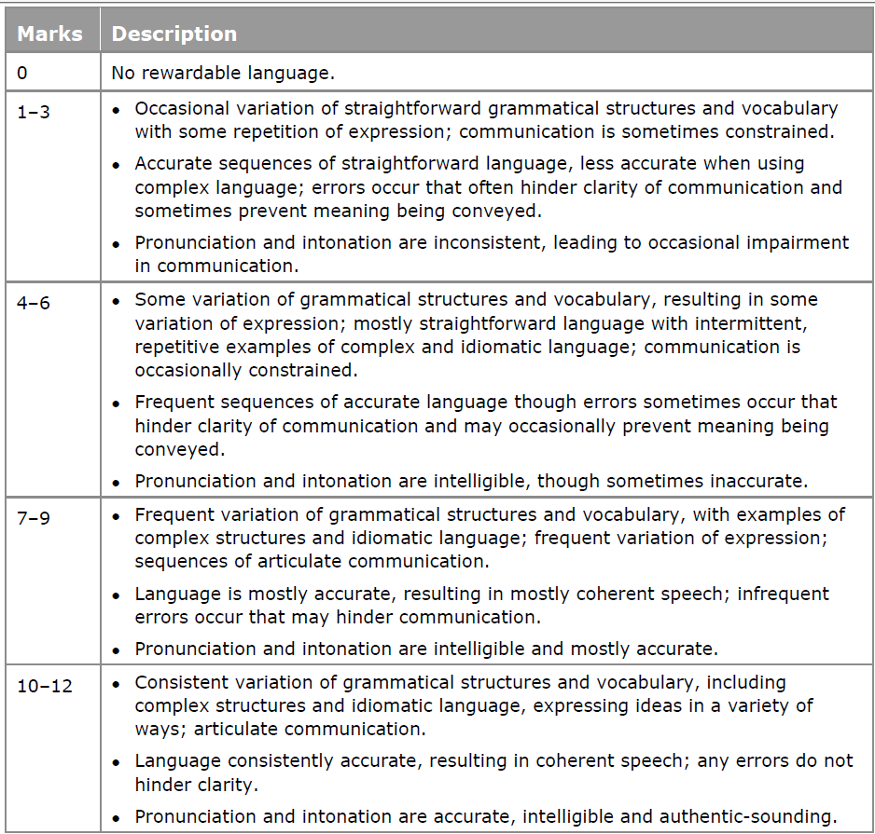
Interaction (AO1)
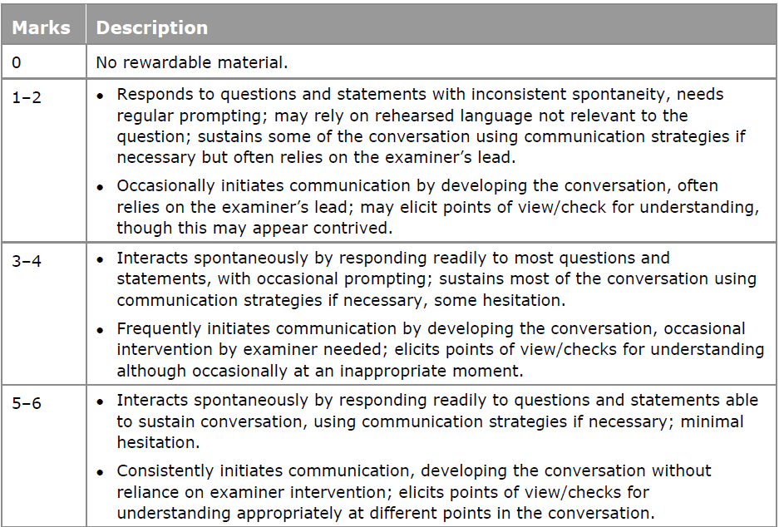

Paper 2 EXAM TIPS
WRITTEN RESPONSE TO WORKS AND TRANSLATION- 2 hour and 40 min, 120 marks, 30% of the qualification

- The exams:
  - Translation – Section A (20 marks) 25 minutes (recommended timing):
You are given one unseen text in English and must translate it into Spanish for
20 marks.

Section B and C (50 marks each) (written response to works), 2 hour and 15 minutes (recommended timing)
You must write one essay, either one selected from Section B (literary texts) or
one from Section C (films)
there will be a choice of two questions for each literary text and film. It is recommended
that, in order to give a detailed analysis of the work, you write between 275–300
words for each essay, giving justified points of view, arguments and conclusions with
evidence from the work. The whole essay will be marked regardless of length.
. In order to achieve high marks in this task, you need to make sure they do the following:
• Address each point of the stimulus carefully. The strongest answers will flow through the bullet points.
• Approach the task creatively. The ability to do that is part of the task. ‘Truth’ is not assessed but content can only be rewarded if it relates clearly to the task set.
• Write within the prescribed word limit. Only points made within the prescribed word limit can be rewarded.
• Write with grammatical accuracy.
• Use appropriate register.
• Avoid Anglicisms.
Remember: Make sure you organize the piece of writing with similar amount of words for each paragraph and the topics in the bullet points do not have to be mentioned in the same order, but they all have to be mentioned.
Make sure you answer the question given, focus on using a wide variety of vocabulary, with good structures that make your work ‘flow’ nicely. Accuracy is also important so make sure that you leave enough time to check through your work at the end. Use your imagination & make sure you address the task. Check verbs- tense & person + endings, check adjectival agreements and remember you want to try to include a variety of structures and tenses eg:
- en cuanto a; en lo que concierne a
- Impersonal ‘se’ phrases, e.g. se dice que, se puede, se debería
- Adverbs : probablemente
- Negative, e.g. ningún, nadie, nunca
- Seguir + gerundio
- Advanced opinions: A mi modo de ver, no cabe duda de que

Check spellings and remember you are in control – it’s your opportunity to shine and show the progress you’ve made since GCSE– if you know something is incorrect –do not use it!

You must try to keep to the approximate timings for each section or else you will find that you will run out of time!

WHAT CAN I DO TO REVISE?

- Revise key vocabulary from the topics covered throughout the year (see below) but it is also a good idea to look over GCSE vocabulary too.
- Look through previous Listening, Reading and Writing practice, especially past papers.
- Revise verbs, tenses and grammar points covered this year (see list below)
- Use your grammar notes the Unit 2 Vocabulary book to help you
- Use useful revision sites (look at the sites listed at the end of this booklet)

GRAMMAR

- Nouns
- Quantifiers/Intensifiers
- Adjectives
- Comparisons
- Possessives
- Adverbs
- Pronouns
- Prepositions
(personal a, por and para)
- Conjunctions
- Negatives
- Continuous tenses and gerunds
- Subjunctive mood
- ‘Ser’ and ‘Estar’
- ‘Por’ and ‘Para’
- Verbs – regular, irregular, reflexives, radical changing (in all tenses), preterit, perfect, future, conditional, imperfect, pluperfect and future perfect.


WRITING TASKS EXEMPLAR

1. La televisión
La televisión ¿fuerza positiva o negativa en nuestra sociedad?

2. La publicidad
Con el uso de ejemplos, explica tu opinión de la publicidad que vemos en los medios de comunicación

3. Las tecnologías de la comunicación
Muchos dicen que ahora las desventajas del Internet son más grandes que las ventajas. ¿Estás de acuerdo, si o no?

4. El cine
Con el uso de películas que has visto, describe las diferencias entre los varios certificados. ¿Es necesario mantener estas categorías o deberíamos abandonarlas?

5. La música
La música es algo que define nuestra identidad, tanto personal como nacional. ¿Estás de acuerdo?

6. La moda
¿Es la imagen personal demasiado importante hoy en día?

7. El deporte
¿El deporte y el ejercicio son importantes para los jóvenes hoy en día?

8. La salud y el bienestar
¿Por qué no dejar a los jóvenes disfrutar del botellón en paz?

9. El turismo
El turismo ha tenido un impacto muy negativo en España. ¿Estás de acuerdo?

10. La familia
Los jóvenes no valoran a la familia: ni a las personas, ni la idea. ¿Estás de acuerdo?

11. Las amistades
¿Cuándo, cómo y por qué son importantes hoy en día?

12. El matrimonio
¿El matrimonio aún sirve hoy en día o existen otras opciones mejores?

MARK SCHEME
SECTION B & C- Writing
You will have to respond to ALL bullet points. You must write 270-300 words.

Critical response (AO4)

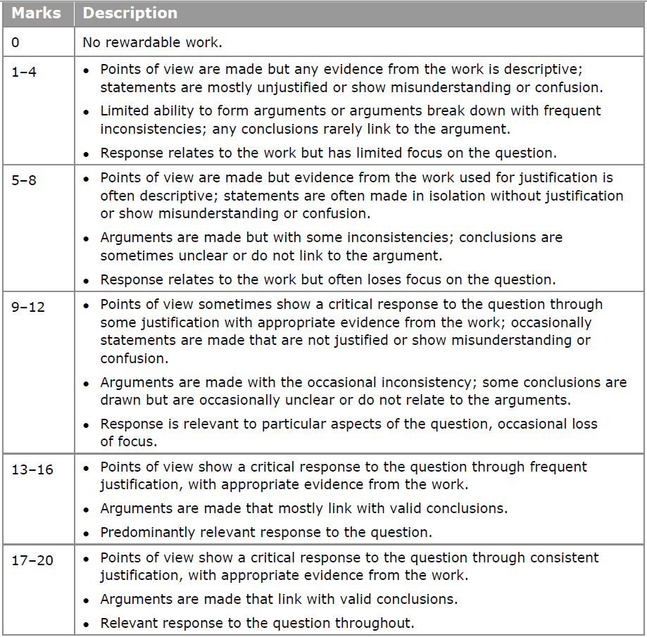

Accuracy and range of grammatical structures and vocabulary (AO3)

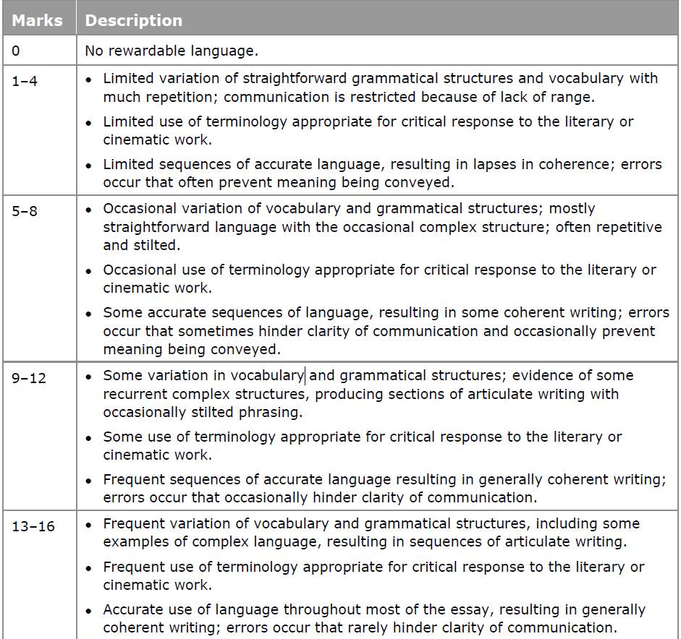
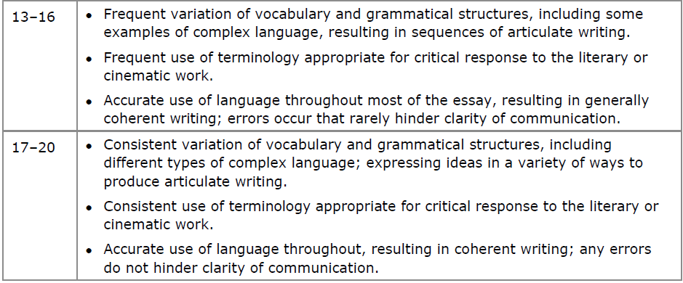

ESSAY WRITING TIPS

Your essay should consist of 3 main sections:

- The introduction

- Put the question in context. E.g. why are people talking about this issue? Why is it important? Has a recent event made it topical? How about starting with an interesting fact or statistic?

- Then say what you are going to do in your essay – stick to the essay title!

- The main body of the essay

Depending on the essay question, you may need to divide this section into an “arguments pro” part and “arguments cons” part. Remember, 2 or 3 arguments for each part is generally enough.

For each argument, remember, one idea per paragraph and for each paragraph:

- What is my point?
- Where is my evidence?
- How does this answer the question?
- How can I link this to the next point?

Keep your reader with you. You are taking them for a walk - don’t let them go!

- The conclusion

Sum up the main points you have made throughout the essay – DON’T introduce new ideas. Give your opinion if possible. Finish, if you can, with something which could be important to your topic in the future.

Finally

- Do a systematic error check using the checklist below.

- Does your language read above GCSE level? Can you bring more interest and complexity to your language?

Really useful writing tips

- Avoid phrases like pienso que…/creo que…. If you want to make clear you are expressing a personal opinion use: en mi opinión, desde mi punto de vista or a mi modo de ver; or a more sophisticated expression like: estimo que… or considero que…or even tengo que admitir que…or quisiera añadir que…

- Avoid phrases like mucha gente piensa que. If you want to express a commonly held view, say:como se sabe, teniendo en cuenta(consideración) que, como es bien conocido por todos, considerando que

- Do not overuse the word problema. Try el tema (en cuestión) (issue) or el tópico (topic) or la polémica (debate) or el asunto (matter)

- Use good sentence starters: se puede notar que, no se puede negar que…, es obvio que…, lo primero que hace falta decir es que, no cabe duda de que….

- Use linking phrases to start new paragraphs: siendo eso así …, dicho eso…, no se debe olvidar que …, lo que demuestra que…

- Try to include subjunctives

- Use rhetorical devices:

Rule of three – la televisión es informativa, omnipresente , pero adictiva
Contrast – por un lado…, por otro lado…/por una parte…por otra parte…
Interjections – ¡Qué horror! ¡Qué desastre!
Rhetorical questions – ¿Quién puede dudar eso?
Proverbs or sayings –poner algo patas arriba, la mejor defensa es un ataque, más vale prevenir que luego lamentar, más vale tarde que nunca…
Emotional appeal – imagina si estuvieras desempleada, ponte en el lugar de…
Imagery –

- Don’t use decir – try afirmar/declarar/pretender/comprobar

- Don’t use ser/estar – try representar/constituir/encontrarse

- Don’t use tener – try disponer de/poseer/ofrecer/ejercer

- Don’t use causar – try provocar/acarrear/producer/llevar a

- Do not overuse the phrase hay. Try existe/se encuentra

- Don’t use mucho/a(s) – try un buen número de/una cantidad importante de

- Avoid weak and vague adjectives like bueno/malo/fuerte/interesante/importante. Try favorable/dañino/persuasivo/fascinante/indispensable/perjudicial/beneficioso
ESSAY TERMINOLOGY

★ INTRODUCTORY REMARKS
Primeramente  En primer lugar  En segundo lugar  Voy a hablar de/Me gustaría hablar /analizar/  Vamos a estudiar…  El tema que he elegido es…  La pregunta que me gustaría abordar es  Lo que encuentro más interesante es….  Me gustaría examinar el tema de…  Es necesario que nos preguntemos….  Vamos a considerar dos aspectos del problema....  Para clarificar el problema vamos a observar….  Debemos considerar las ventajas y desventajas….  De todos es sabido…. | First of all  First(ly)  Secondly  I am going/ we are going to talk about/  We are going to examine/ study  The theme I chose to study is…  The question I want to ask/ address is…  What I find most interesting is…  I would like to look into the topic of…  It is necessary to ask ourselves whether…  We have to consider two aspects of the problem  In order to clarify the problem, we are going to observe...  We have to weigh the pros and cons  It is well known…

★ PERSONAL COMMENTS
En mi opinión  En lo que a mí me concierne  Por mi parte  En mi caso  Desde mi punto de vista  Pienso que  Creo que  Encuentro que  Me parece que  Estoy segura que  Estoy convencido/a que  Yo diría que  Me inclino a creer que | In my opinion  As far as I am concerned  For my part  As for me  From my point of view  I think that  I believe that  I find (that)  It seems to me that  I am sure that  I am convinced that  I would say that  I am inclined to believe that

★ IMPERSONAL EXPRESSIONS
Es necesario precisar que  Es importante tener en cuenta que  Es evidente que  Es incuestionable que  Es posible distinguir  Se debe resaltar que  Sería más correcto decir que  Nos hace pensar que  Parece claro/evidente que  Basta decir que  Hoy en día hay una tendencia a decir que | It is necessary to specify that…  It is important to take into account  It is obvious that…  It is unquestionable that…  It is possible to distinguish  One must point out that…  It would be more accurate to say that…  There is ground for thinking that…  It seems clear that…  Suffice (it) to say that…  Today there is a tendency to say that…
★ CAUSE AND EFFECT RELATIONSHIPS
Por consiguiente  Así que  Por lo tanto  Por esta razón  Es decir  Además  Entonces  Esta es la razón por la que  Se deduce que  Se piensa que  Se puede entender que  Podemos interpretar que  Este estudio revela que  Este ejemplo prueba que  Este párrafo nos muestra que  No hace falta decir que | Consequently  Therefore  Thus  For this reason  That is to say / namely  Besides  Then  That’s why  It can be deduced that…  It can be thought that…  It can be understood that…  We can interpret this as…  This study reveals that…  This example proves that…  This passage shows that…  It goes without saying that…

★ CONTRADICTING
Pero  Sin embargo  Por el contrario  En realidad  Por un lado …./ por una parte  Por otro lado / por otra parte  Más que  Aunque  Incluso si  A pesar del hecho de que / a pesar de  En realidad  De hecho | But  However  On the contrary  Actually  On one hand…  On the other hand  Rather  Although  Even if/ even though  Despite the fact that  To tell the truth  In fact

En conclusión  Para resumir / para concluir  Finalmente / para terminar /  En pocas palabras / en una palabra  Brevemente  Habiendo considerado todos los aspectos  En conjunto  Como hemos explicado  Como hemos dicho  Como hemos resaltado / subrayado antes  Esto muestra que  Esto demuestra que  Podemos concluir que  Hemos llegado a la conclusión de que | In conclusion  To sum up  Finally  In a few words / In a word  In short  All things considered  All in all  As was explained  As was stated  As was pointed out earlier  This shows that  This demonstrates that  We can conclude that  We have reached the following conclusion that
★ CONCLUSION

WRITTEN WORK CHECK GRID
FECHA:
TEMA:
- Planned an outline (essays: intro, main body of 2-4 points for pros and for cons, opinions, conclusions, solutions)
- Tenses (pret/ imp/ plup/ perf/ past cont/ pres cont/ pres/ fut perf/ cond perf/ fut/ fut cont/ cond..)
- Person of verb (yo/ tú..)
- la mayoría/ la gente/ la ciudad= singular
- Personal A (But not when it is doing action: el hombre hacía... Vi al hombre
- Prepositions after verbs (a/ con/ de/ sobre...)
- Adjectival agreements (la chica guapa
- Correct gender for nouns (el hombre/ la participación/ el problema/ el sistema)
- Por/ para (para + inf, por + time..)
- Passive (ser + past participle agreeing: fue matado por…- he was killed by...)
- Avoidance of passive (se bebe el vino- Wine is drunk*)
- Accents ( la declaración/ las declaraciones)
- Spellings (use dictionary to help you)
- Appropriate register of language used (high/ technical/ complicated for essays)
- Essay expressions (se debe mencionar que/ es imprescindible que se mencione…)
- Subjunctives (checked endings: regular/ irregular)
- Subjunctives (used correctly with phrase in correct tense)
- Checked work thoroughly before handing in?
- How long did I take to do it?
Complete with the date and note down what topic your essay was on, and run through the checklist each time you do one:

TYPICAL SPANISH IDIOMS
Modismos típicos españoles
http://www.geocities.com/athens/thebes/6177/idioms.htm

Al hierro caliente batir de repente Beat the hot iron at once. Strike while the iron is hot

Antes que te cases mira lo que haces Before you marry look what you do Look before you leap

Beben agua en el mismo jarrito They drink water from the same little jug They are as thick as thieves

Cada perico a su estaca, cada changa a su mecate Each parrot on its perch, each monkey on its rope. To each his own

Caras vemos, corazones no sabemos Faces we see, hearts we don't know Can’t judge a book by its cover

Darle un beso a la botella. To give the bottle a kiss To have a swig

De la subida más alta es la caída más lastimosa. Of the highest rise, the shortest fall. The bigger they are the harder they fall

En menos que canta un gallo. In less time than the rooster crows In a shake of a lamb’s tail

Estar como perro en barrio ajeno. To be like a dog in a neighbor's yard To feel like a fish out of water

Más loco que una cabra Crazier than a goat mad as a hatter

Más vale pájaro en mano que ciento volando. A bird in the hand is worth more than a hundred flying A bird in the hand is worth two in the bush

Meter la cuchara To put the spoon in put your oar in

Mientras que en mi casa estoy, rey soy While in my house, I am king. A man’s home is his castle

Ser más listo que un coyote To be more ready (alert) than a coyote sharp as a tack

Tener más lana que un Borrego To have more wool than a lamb To have money to burn

Vivito y coleando Alive and wagging tail alive and kicking

Al que madruga, Dios lo ayuda The early Bird catches the worm

No hay nada tan atrevido como le ignorancia Fools rush in where angels fear to tread

El campo fértil no descansado, tórnase estéril All work and no play makes Jack a dull boy

Al canto del petiguere At the cock’s crow/At Day break

REALLY USEFUL SPANISH WEBSITES and how to use them best!


TO WORK ON YOUR LISTENING

You should select a short audio or video clip from the Internet. Play the clip at least three times and write a brief summary in Spanish (it needn’t be any longer than 50 words) with a vocabulary list of at least 10 words. These could be key words or they could be words that are new to you and had to be looked up.
It is easier to start with short news bulletins. Video clips are ideal as they are easier to understand. Start with shorter clips and then when you feel ready, you could choose a radio programme from the Radio station websites listed below.

Spanish News
www.euronews.net
Select language ‘español’ and then choose from a wide variety of News videos.
www.20minutos.es/
es.news.yahoo.com/
Follow the link to Video Noticias for three-minute news clips.
es.noticias.yahoo.com/

Spanish TV channel websites:
www.antena3tv.com
Choose from the menu for the topic area you are interested in and then browse for video clips:
www.antena3videos.com/

For news, browse for videos at:
www.informativos.telecinco.es/
www.canalsur.es
Click on the link to TV “en directo” (live) and you will be able to watch the channel on streaming video.
www.informativos.telecinco.es/reproductor_video.htm

For celebrity gossip....
es.celebrities.yahoo.com/
Click on “Perfiles de Famosos”

Spanish Radio on-line
www.rtve.es/rne/envivo.htm
Select a radio station from the list.
www.topradio.es/
Easy listening music radio station for Spanish and English / American pop music.
www.lyngsat.com/freeradio/
Spain.html
Selection of the most important radio channels

TO WORK ON YOUR READING


Select an article which interests you, read it carefully and select at least 10 new pieces of vocabulary to look up. The choice of topic area is limitless. The temptation may be to pick an article on fashion, but you should avoid doing this every week as they are not so easy to understand. It is a good idea to vary the topic area and to choose articles related to the syllabus topics so that you encounter a variety of vocabulary.

www.bbc.co.uk/languages/spanish/news
The best place to start is the BBC’s languages web-pages. Choose the “reportajes” link to find articles from the former “Semanario Internet” with a variety of reading exercises. The articles are
archived into topic areas that relate to the AS and A level syllabus.
Some of them include audio clips so you can base your listening task on the same topic.
www.elmundo.es
Spanish daily newspaper. The website gives you access to all of the day’s news articles.
www.elpais.es
Spanish daily newspaper. The website gives you access to the day’s news articles although you may require a subscription to view the majority of the articles in full.
es.news.yahoo.com/
http://www.publico.es/
www.terra.es
On-line Spanish daily news.
www.donbalon.es/front/
Spanish football website with related articles.
www.hola.com
Spanish celebrity gossip magazine. Subscription required to view some of the articles.
www.terra.es ( archive news)
www.marca.es (sport)
www.estrelladigital.es

