Name:

Core Organic Chemistry
End of Module Test
Question | Marks
1 | /14
2 | /10
3 | / 5
4 | / 5
5 | / 3
6 | / 8
7 | /15
Total | /60
Grade

- Crude oil is a source of many hydrocarbons.
The skeletal formulae of some of these hydrocarbons are shown below.
  - Explain why compound A is both saturated and a hydrocarbon.

[2]
  - What is the empirical formula for component A?
[1]
  - Give the letters A, B, C, D, E, F, G, H or I, of two hydrocarbons that are structural isomers of each other.
and [1]
  - Explain why hydrocarbon D has a higher boiling point than hydrocarbon C.

[2]
  - Hydrocarbons G and H are stereoisomers of each other.
Explain what is meant by the term stereoisomer.

[2]
  - Construct the equation for the complete combustion of hydrocarbon C.
[2]
  - A hydrocarbon molecule, C₁₆H₃₄, is cracked to form an octane molecule and two molecules of but-2-ene.
Construct the equation for this reaction.
[2]
  - Compound I is 3-methylheptane. It does not contain a functional group.
    - What is meant by the term functional group.

[1]
    - Compound I reacts with chlorine in the presence of ultraviolet radiation to give several structural isomers of C₈H₁₇Cl.
How many structural isomers could be formed in this reaction?
[1]
    - The mechanism of the reaction involves radicals.
What is meant by the term radical?

[1]
[Total: 14]

- Ethanoic acid, CH₃COOH, is used to make esters.
Some information about two of the processes used to make ethanoic acid is given below.
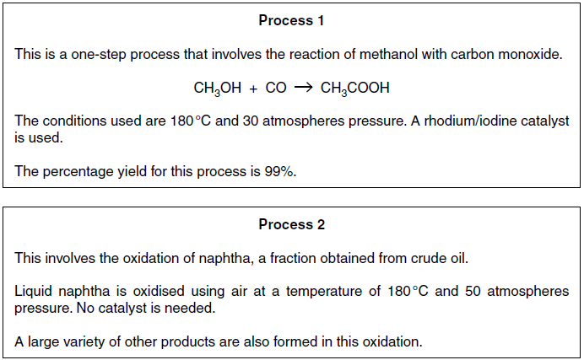
  - Suggest three advantages of making ethanoic acid using Process 1 rather than Process 2.

[3]

  - The other products formed in Process 2 are carboxylic acids, aldehydes and ketones.
A research chemist investigates some of these other products of Process 2.
    - The research chemist isolates product J.
The infrared spectrum of J is shown below.
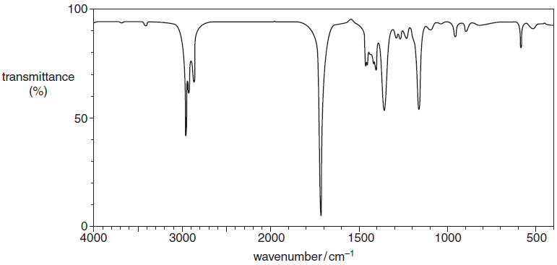
The chemist also finds that 0.172 g of pure sample J contains 2.00 x 10^{–3} mol of J.
Suggest, with reasons, one possible structure for J.
In your answer you should link the evidence with your explanation.

[5]

    - The chemist isolates another product, the carboxylic acid K.
K has the molecular formula C₄H₈O₂.
Suggest a possible structure and name for K.
Structure

Name [2]
[Total: 10]
- The mechanism of the reaction between H_{2(g)} and Cl_{2(g)} involves initiation, propagation and termination.
  - The initiation step is the homolytic fission of the covalent bond in a chlorine molecule.
Write an equation to show this homolytic fission.
[1]
  - Complete the following equations which show the propagation steps.
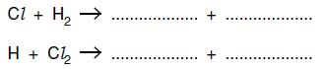 [2]
  - Suggest equations for two termination steps.

[2]
[Total: 5]

- Concentrated H₂SO₄ is used as an acid catalyst in the elimination of water from alcohols.
There are several alcohols that are structural isomers with the formula C₅H₁₁OH. When these alcohols are
heated with H₂SO₄ they form alkenes.
C₅H₁₁OH → C₅H₁₀ + H₂O
  - Pentan-1-ol is a structural isomer of C₅H₁₁OH that is a primary alcohol.
Draw the structure of another structural isomer of C₅H₁₁OH that is a primary alcohol.

[1]
  - Pentan-2-ol is a structural isomer of C₅H₁₁OH that is a secondary alcohol.
Pentan-2-ol is heated with H₂SO₄.
There alkenes are formed, L, M and N.
- L and M are stereoisomers.
- N is a structural isomer of the stereoisomers L and M.
Draw the structure of the alkenes L, M and N.
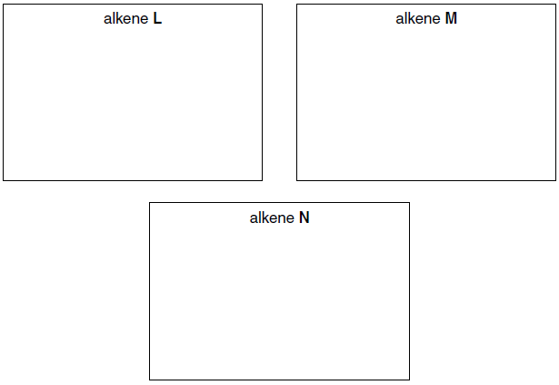 [3]
  - One structural isomer of C₅H₁₁OH is an alcohol that cannot be oxidised by heating with acidified potassium
dichromate(VI).
Draw the structure of this alcohol.

[1]
[Total: 5]
- Mass spectrometry is used in analysis.
Compound O contains carbon, hydrogen and oxygen.
The mass spectrum of compound O is shown below.
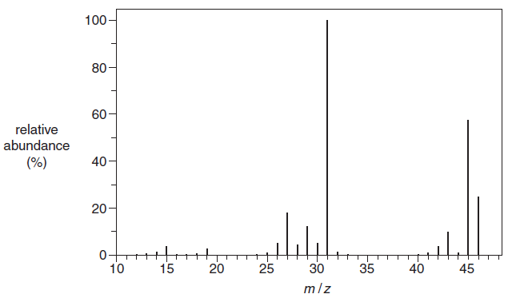
  - Identify the m/z value that corresponds to the molecular ion.
[1]
  - Write the formula of the ion that gives rise to the peak at m/z = 31.
[1]
  - Suggest the molecular formula for O.
[1]
[Total: 3]

- Chlorofluorocarbons, CFCs, were once used as propellants in aerosols. CFCs contribute to ozone depletion in the
upper atmosphere.
  - A CFC has the formula of CF₂Cl₂.
State the three-dimensional shape of a CF₂Cl₂ molecule and the F-C-Cl bond angle
Shape
Bond angle [2]
  - Two reasons that CF₂Cl₂ was used as an aerosol propellant are that it has low reactivity and will not hydrolyse
in water.
    - State one other reason why CF₂Cl₂ was developed for use as an aerosol.

[1]
    - Suggest why CF₂Cl₂ does not hydrolyse in water.

[1]
  - Explain, with the aid of equations, how the presence of CFCs in the upper atmosphere leads to ozone
depletion.

[3]
  - Why are scientists concerned about ozone depletion?

[1]
[Total: 8]

- Cyclopentene is a cyclic alkene.
  - The flowchart shows some reactions involving cyclopentene and cyclopentanol.
Complete the partial structures in the boxes to show compounds P, Q and R, the main organic products of
the reactions.
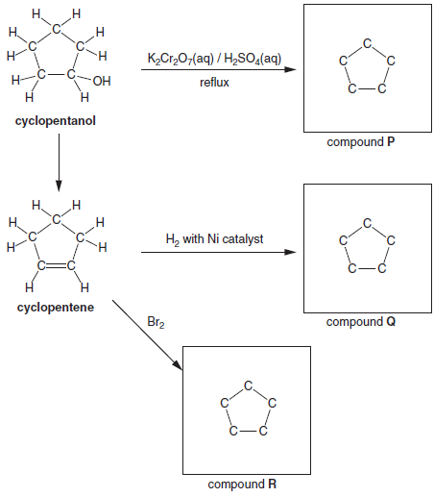 [3]
  - What would be the colour change in the reaction between cyclopentene and bromine?
to [1]
  - Cyclopentene can be polymerised to give poly(cyclopentene).
Draw a section of poly(cyclopentene) to show two repeat units.

[1]

  - Cyclopentene reacts with HCl by electrophilic addition.
Use the curly arrow model to complete the mechanism for this reaction.
In your answer include any relevant dipoles, the intermediate and the product.
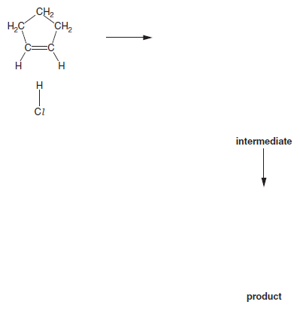 [5]
  - Chlorocyclopentane can by hydrolysed by heating with aqueous sodium hydroxide.
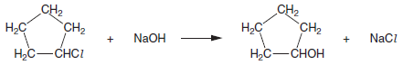
Use the curly arrow model to complete the mechanism for this hydrolysis reaction.
Include in your answer, relevant dipoles, the name of the mechanism and the type of bond fission.
In your answer you should use the correct technical terms, spelled correctly.
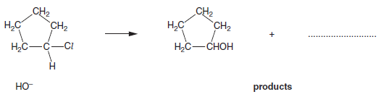
Name of mechanism
Type of bond fission [5]
[Total: 15]

