Name:

Periodic Table & Energy
End of Module Test
Question | Marks
1 | / 3
2 | / 4
3 | / 6
4 | / 3
5 | /10
6 | / 8
7 | / 7
8 | /11
Total | /52
Grade

- Explain the following: Sodium atoms are larger than magnesium atoms.

[Total: 3]

- The flowchart below shows some reactions involving barium. Write the formulae of substances A–D in the boxes.

Ba_{(s)} | heat  air | ……………………..(s)  solid A
 |  | H₂O_{(l)}
 |  | Ba(OH)_{2 (aq)} | HCl_{(aq)} | ……………………..(aq)  Solution B
 |  | CO_{2 (g)} |  | AgNO_{3 (aq)}
 |  | ……………………..(s)  solid C |  | ……………………..(s)  solid D

[Total: 4]

- A student carries out two experiments.
  - The student bubbles some chlorine gas through a solution of sodium iodide. The solution turns a brown colour.

Explain this observation and write an equation for the reaction that takes place.

[2]

  - The student bubbles chlorine gas through aqueous silver nitrate. A white precipitate forms. Explain this observation including equations for any reactions that take place.

[4]
[Total: 6]

- The Group 2 elements become more reactive down the group.
The Group 7 elements become less reactive down the group.

Explain this difference between Group 2 and Group 7.

[Total: 3]

- Glucose, C₆H₁₂O₆, can be used directly as a source of energy in living species or fermented to produce ethanol, C₂H₅OH. The ethanol produced can then be used as a fuel.
  - Energy is released from the oxidation of glucose in living species.
What name is given to this process?

[1]

  - When ethanol is used as a fuel, a combustion reaction takes place. The equation for this process is shown below.
C₂H₅OH (l) + 3 O₂ (g) → 2 CO₂ (g) + 3 H₂O ΔH = –1367 kJ mol^{–1}
The table below shows values for standard enthalpy changes of formation, ΔHº_{f}..

compound | ΔHº_{f} (kJ mol^{–1})
CO₂(g) | –394
H₂O(l) | –286

    - Define the term standard enthalpy change of formation.

[3]

    - Calculate the standard enthalpy change of formation of ethanol.

ΔHº_{f} = ............................................ kJ mol−1 [3]

    - On the axes below draw the enthalpy profile diagram for the combustion of ethanol.
Label E_{a} and ΔH on your diagram.
C2H5OH(I) + 3O2(g)

enthalpy

[3]
progress of reaction [Total: 10]
- Reactions that release energy are essential to maintain many aspects of everyday life.

  - Enthalpy changes can be calculated using average bond enthalpies. Table 1.1 shows some average bond enthalpies.
Bond | Average bond enthalpy (kJ mol^{–1})
C–C | +347
C–H | +413
O–H | +464
O=O | +498
C=O | +805
C–O | +358

Table 1.1
    - Define the term bond enthalpy.

[2]

    - Ethanol, C₂H₅OH, can be burnt to release energy. The equation below shows the combustion of ethanol.
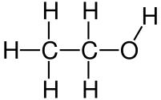 | + | 3 O=O | → | 2 O=C=O | + | 3 H–O–H
Use the data in Table 1.1 to calculate a value for the enthalpy change of combustion of gaseous ethanol, ΔHc.

ΔHc = ................... kJ mol−1 [3]

  - Glucose, C6H12O6, can also be oxidised.
The table below shows some enthalpy changes of formation, ΔHf.

compound | ΔH_{f} (kJ mol^{–1})
C₆H₁₂O₆(s) | –1273
CO₂(g) | –394
H₂O(l) | –286

Use the data to calculate the enthalpy change of combustion, ΔHc, for glucose. C₆H₁₂O₆(s) + 6 O₂(g) → 6 CO₂(g) + 6 H₂O(l)

ΔHc = ................... kJ mol−1 [3]
[Total: 8]

- This question is concerned with some of the graphs you may have seen in your studies.
  - Graph A shows a Boltzmann distribution.

Graph A

    - Label the axes on graph A. [2]
    - Explain, using graph A, the effect of adding a catalyst on the reaction rate.
Include labelled lines of the energies involved on graph A.

[2]

  - Graph B shows the change in mass observed in an experiment used to investigate the rate of a reaction.
Graph B
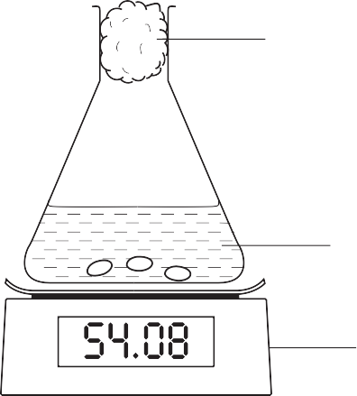
cotton wool

mass
zinc + hydrochloric acid

g balance

time

    - Suggest what is happening in this experiment to produce the loss of mass with time.

[1]
    - Exactly the same experiment was repeated but with a catalyst added.
On graph B sketch the line that would be produced in the presence of the catalyst. [2]
[Total: 7]

- Many chemical reactions are reversible and are able to form equilibrium mixtures.
Hydrogen and iodine react together to form hydrogen iodide in a reversible reaction.
H₂ (g) + I₂ (g) ⇌ 2 HI (g) ΔH= +53 kJ mol⁻¹

  - Explain the following observations when changes are made to an equilibrium mixture of H₂ (g), I₂ (g) and HI (g).
Include reference to the equilibrium position and any other factors.

    - When the temperature is increased the purple colour becomes paler.

[2]

    - When the pressure is increased the purple colour becomes deeper.

[3]

  - The rate at which equilibrium is reached could be increased by increasing the temperature or pressure.

In each case explain why the rate increases:
    - on increasing the temperature,

[2]

    - on increasing the pressure.

[1]

  - H₂(g), I₂ (g) and HI(g) were mixed together and allowed to reach equilibrium. The concentrations of the gases were then measured at various times and the results plotted. At time t, a change was made to the composition of the mixture.

concentration
H2(g)
HI(g)
I (g)
2

t time

    - What change was made to the mixture at time t ?

[1]

    - Explain the changes that happen to the equilibrium mixture after time t.

[2]

[Total: 11]

